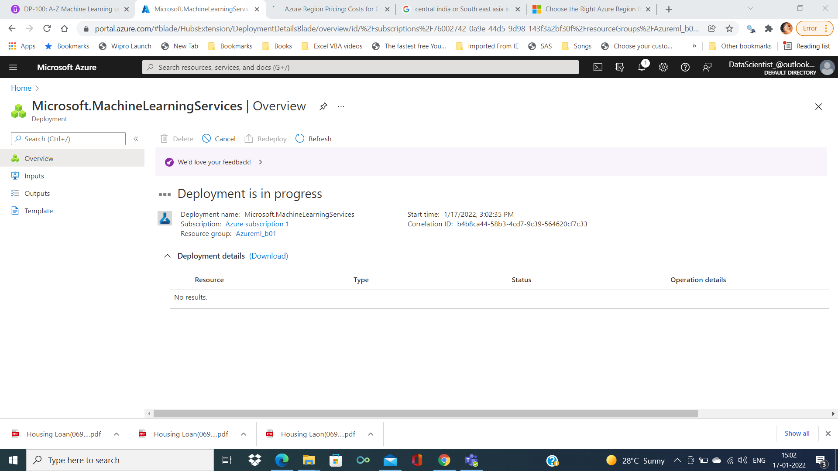

After deployment is completed

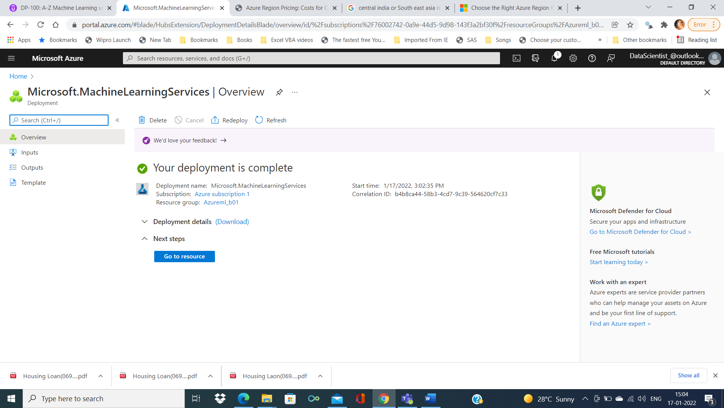

While clicking on ‘Go to resource’

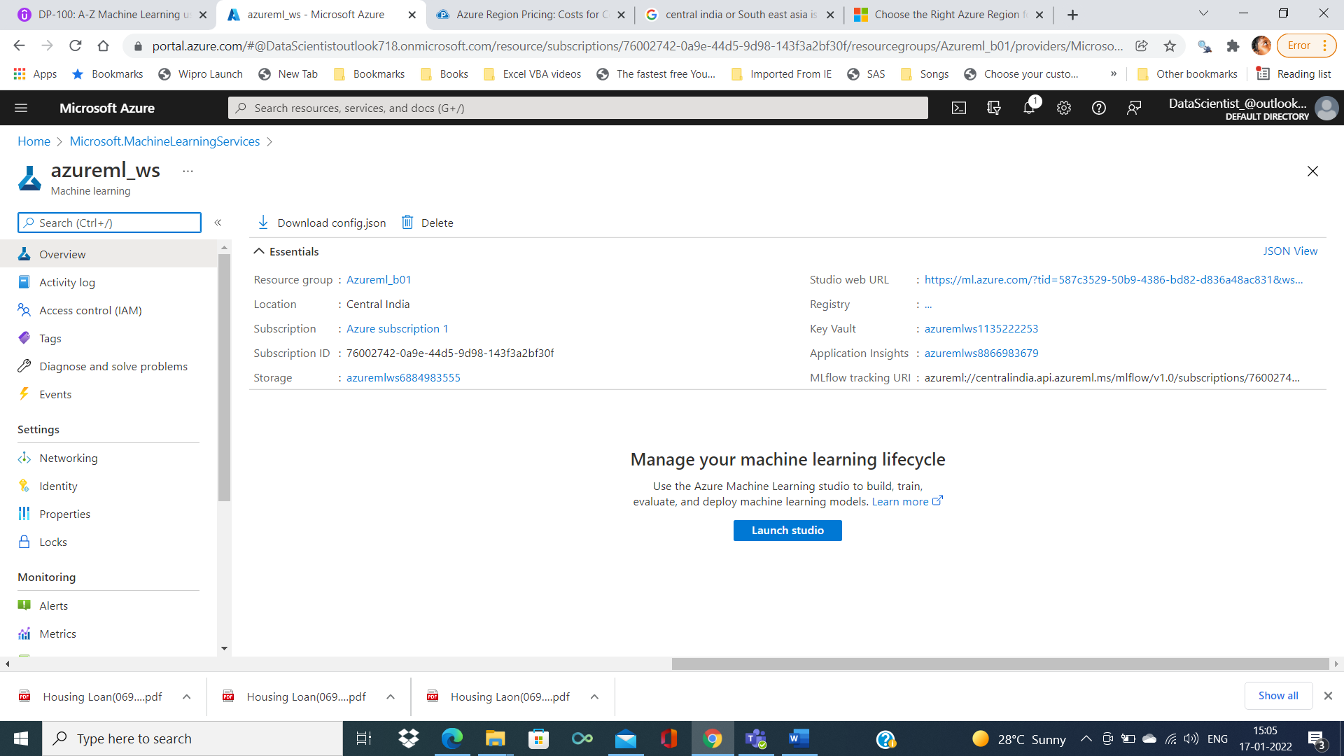

Further need to click on launch studio, will lead to following page which contains all the ML components

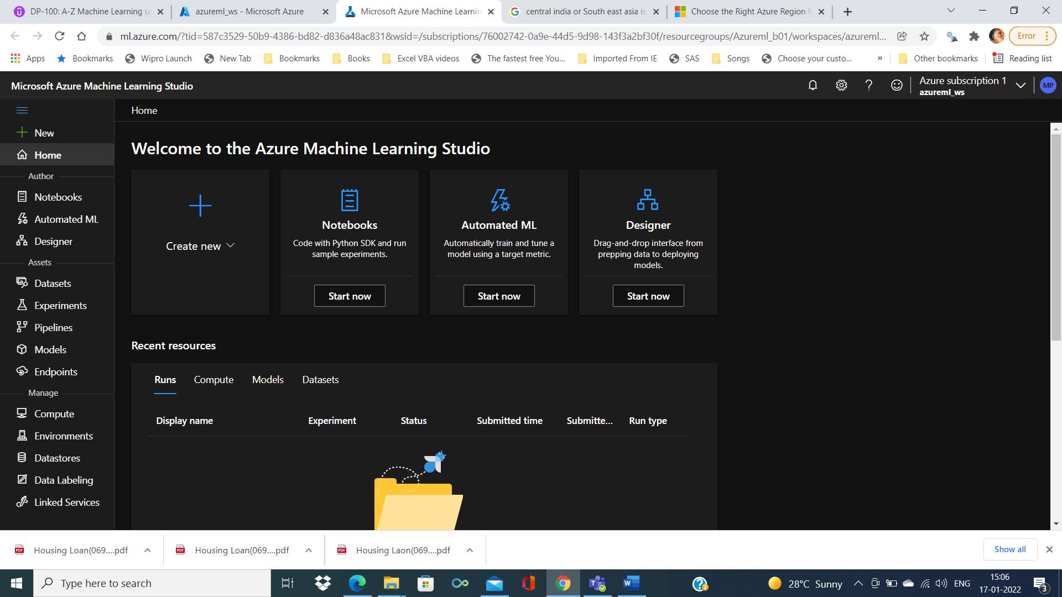

Creating AzureML Datastore and Dataset

Dataset can be procured from the LocalFiles, from web files

Intial stored in Blob Storage , SQL DB ,analytic service

Storage type are azure sql, databricks, PostgreSQL and MySQL,Datalake,files and Blob storage

Using authentication(access Key) we can able to access from the data store (stores the access information) from AzureML workspace for machine learning task

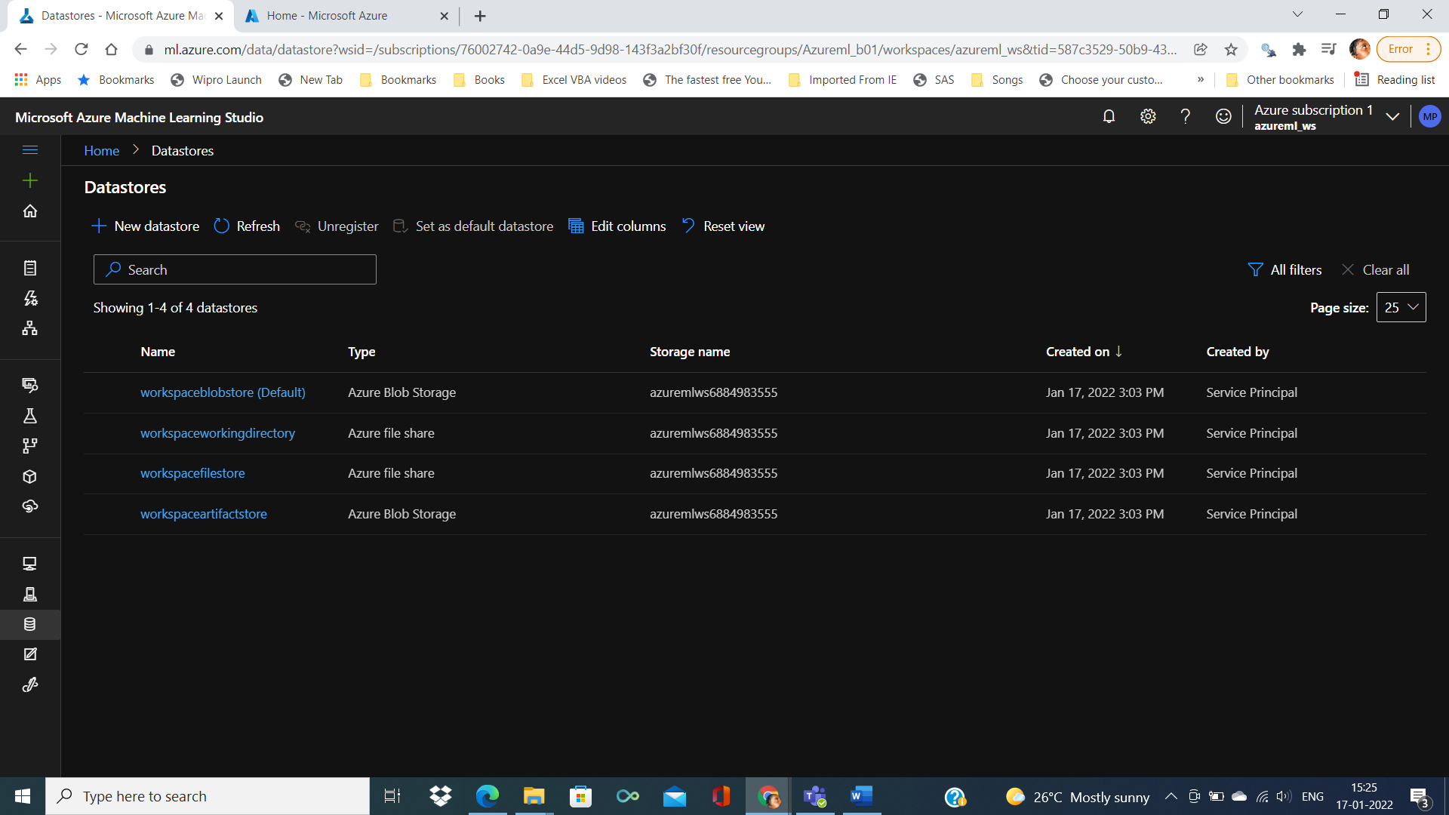

By clicking on azure blob we can able to see the detail information as below

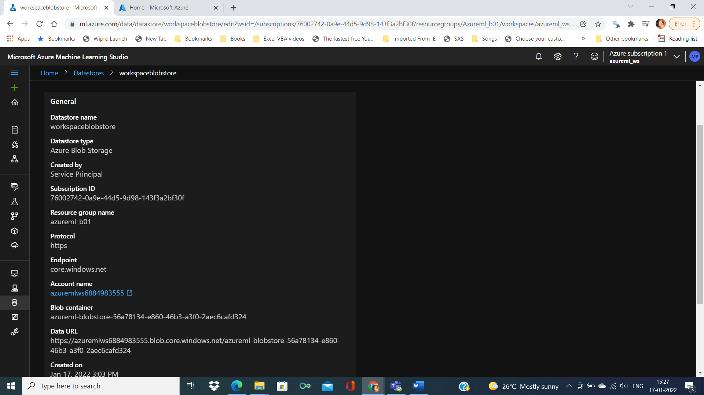

Again by clicking on Account name

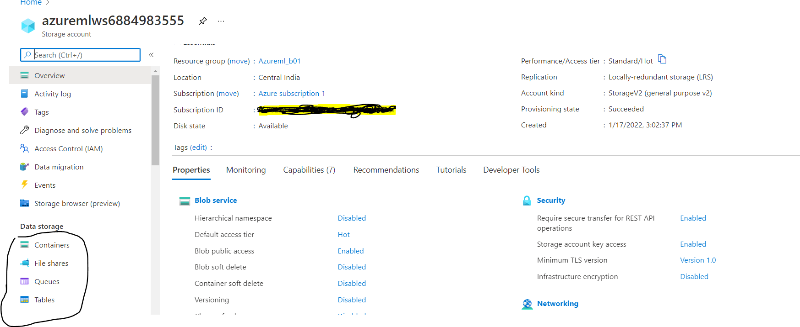

So if we enter into the container we can able to see the blob storage info

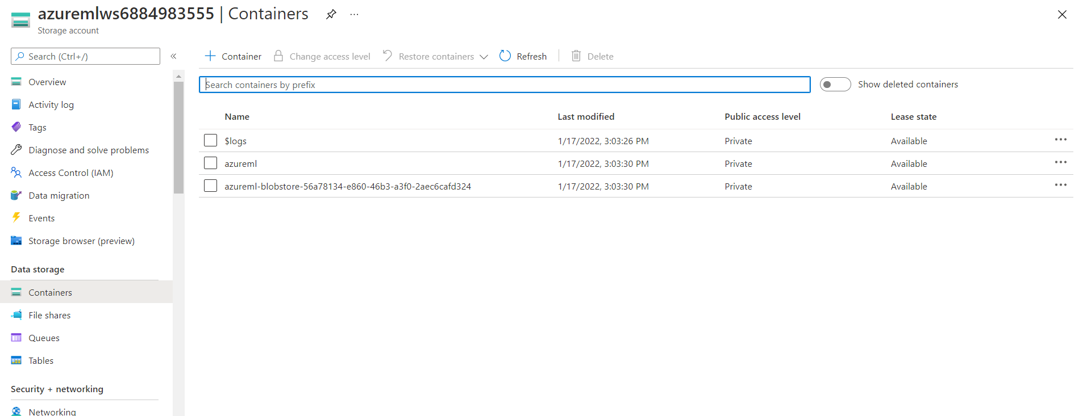

Good practice of storing the external file or dataset is from separate storage account

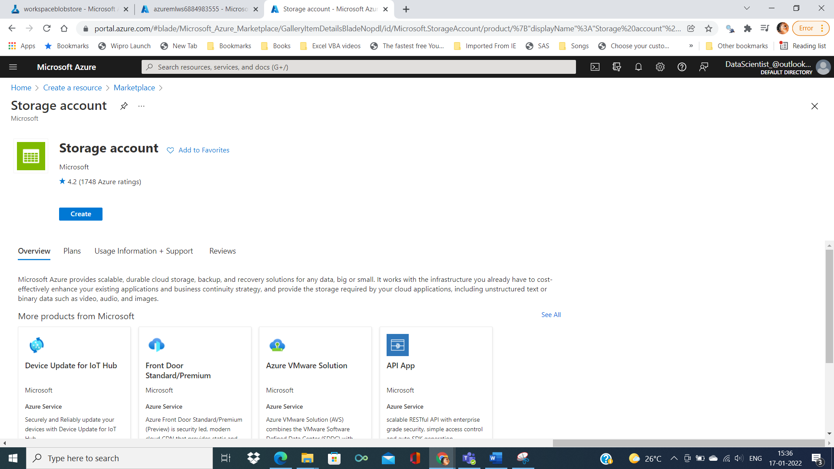

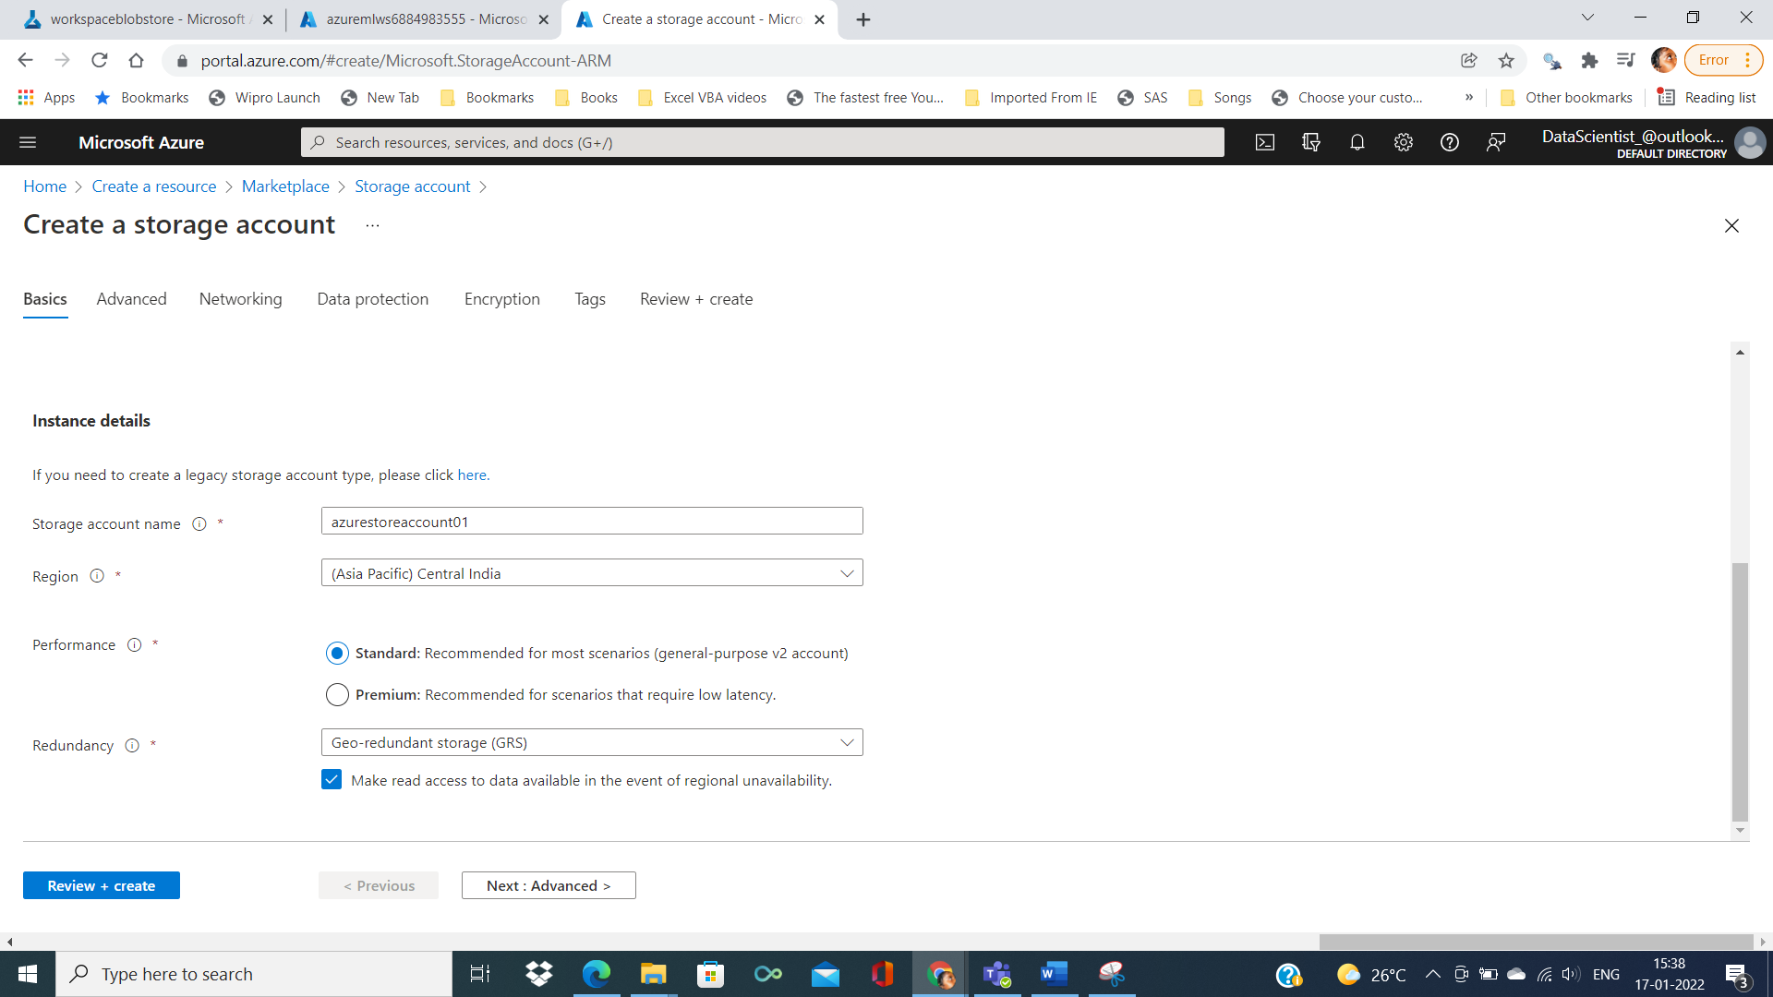

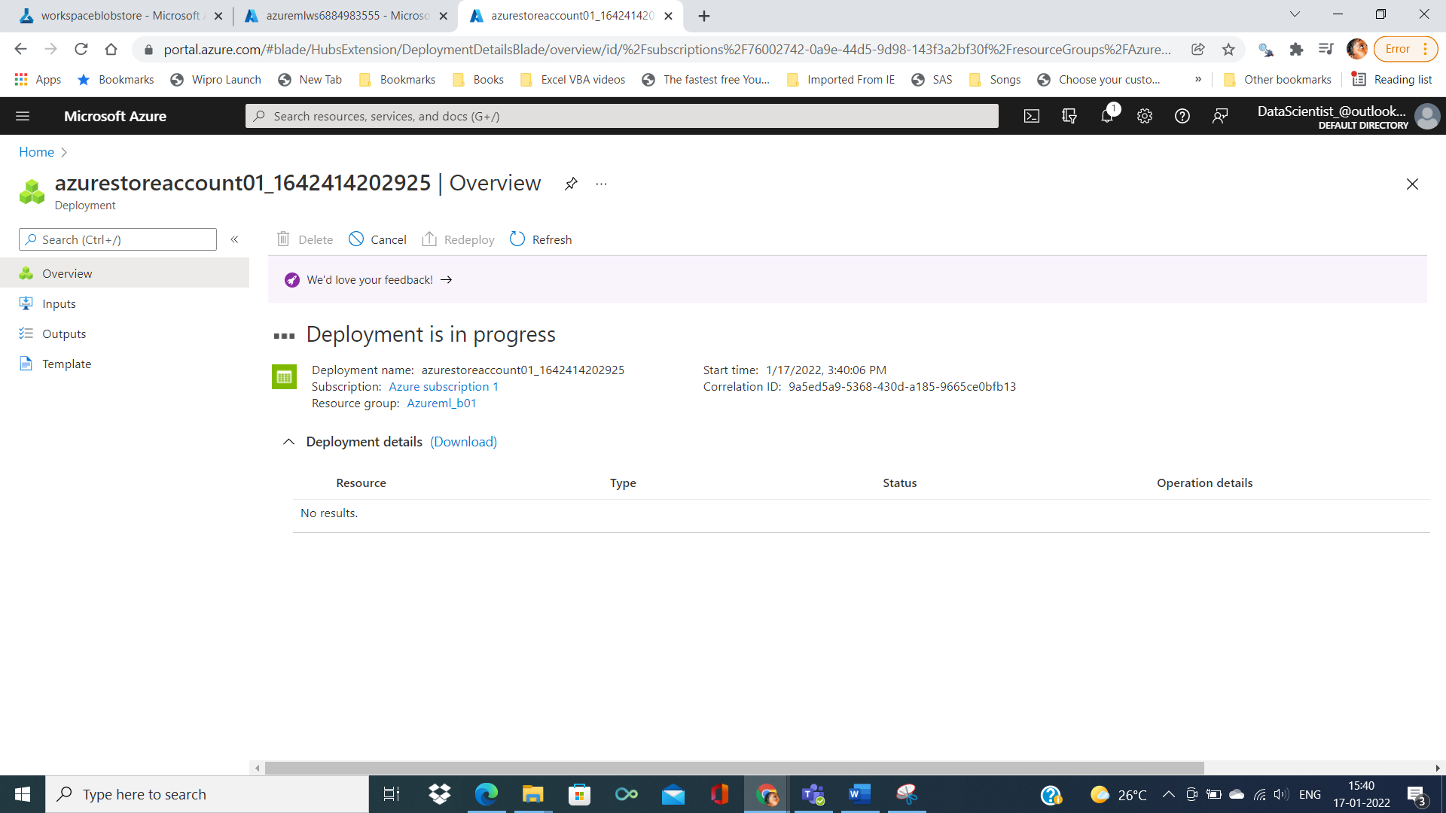

After deployment is completed

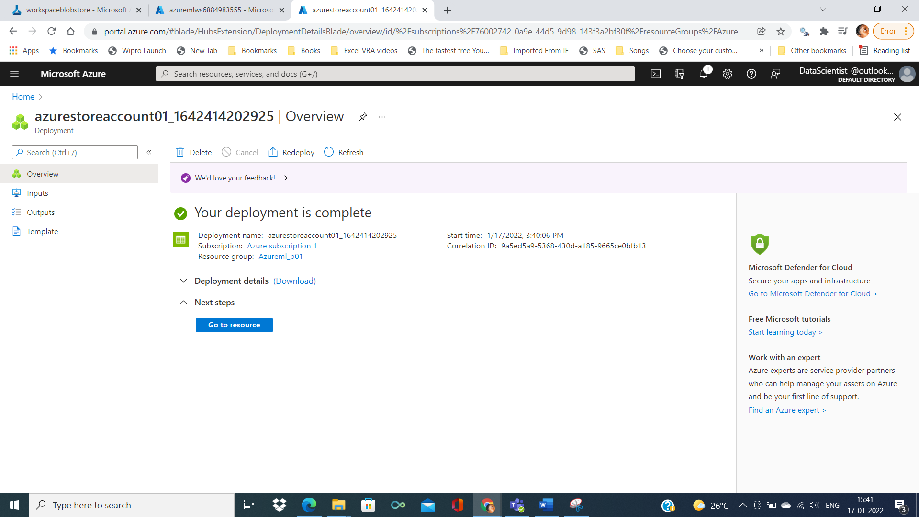

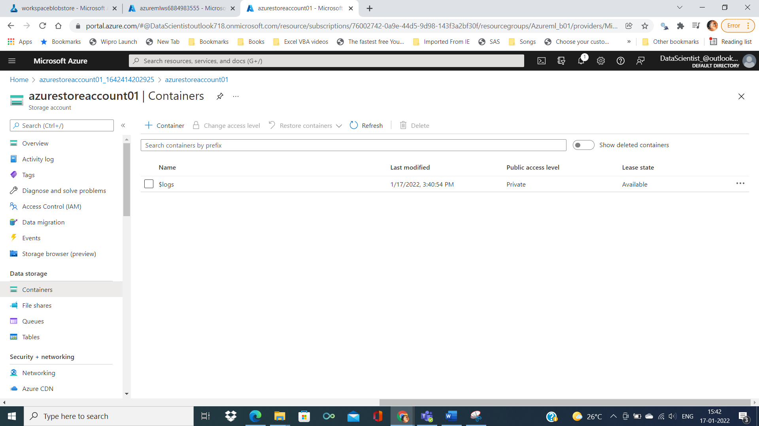

Creating the container

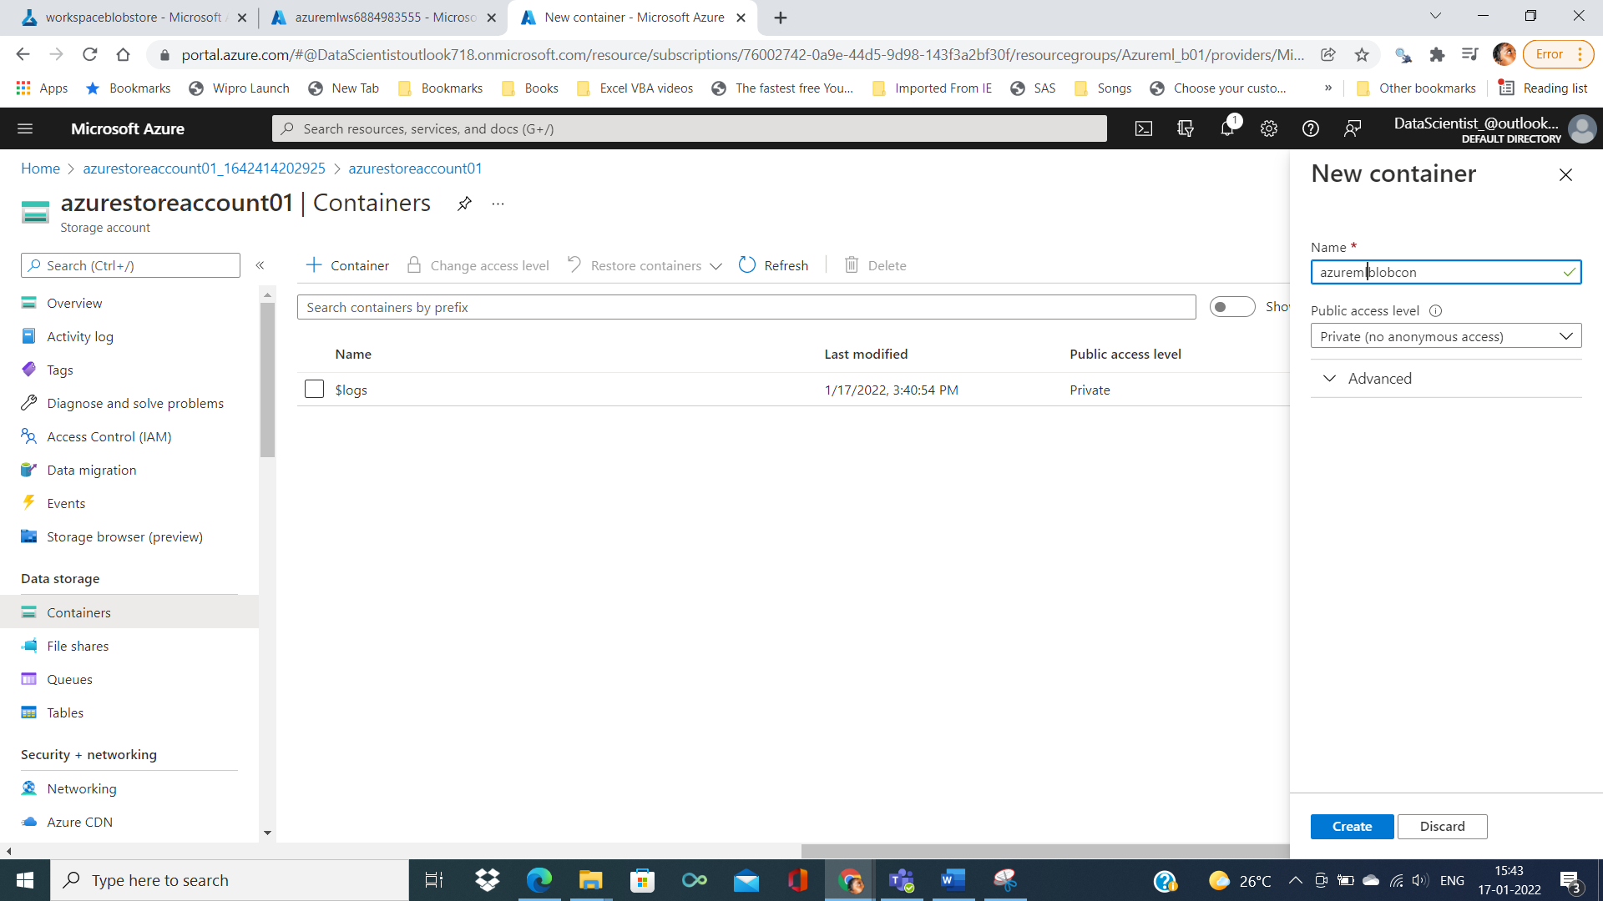

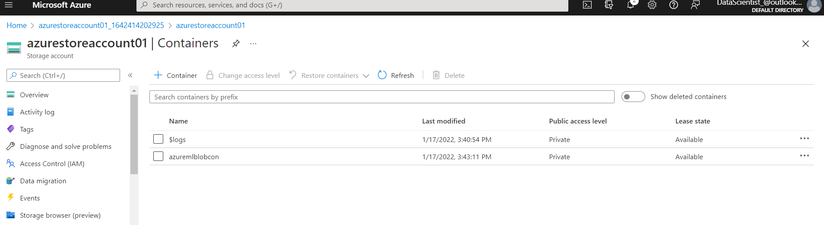

By clicking on the new container we can see the empyt blob

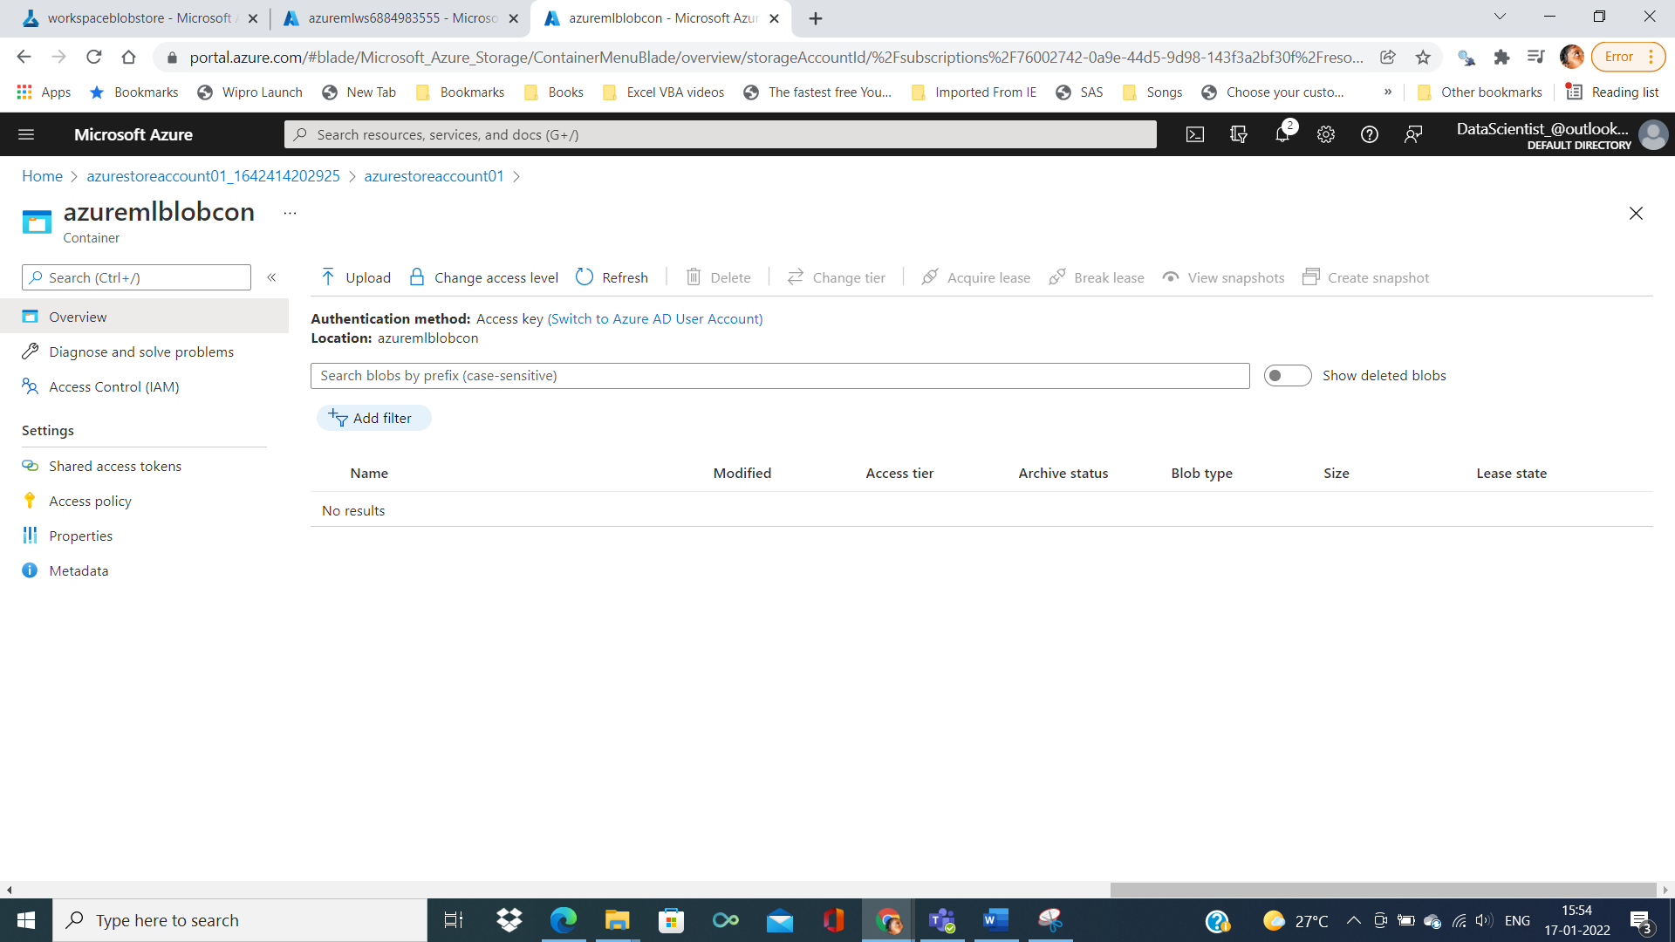

Final created the storage account

Creating new datastore

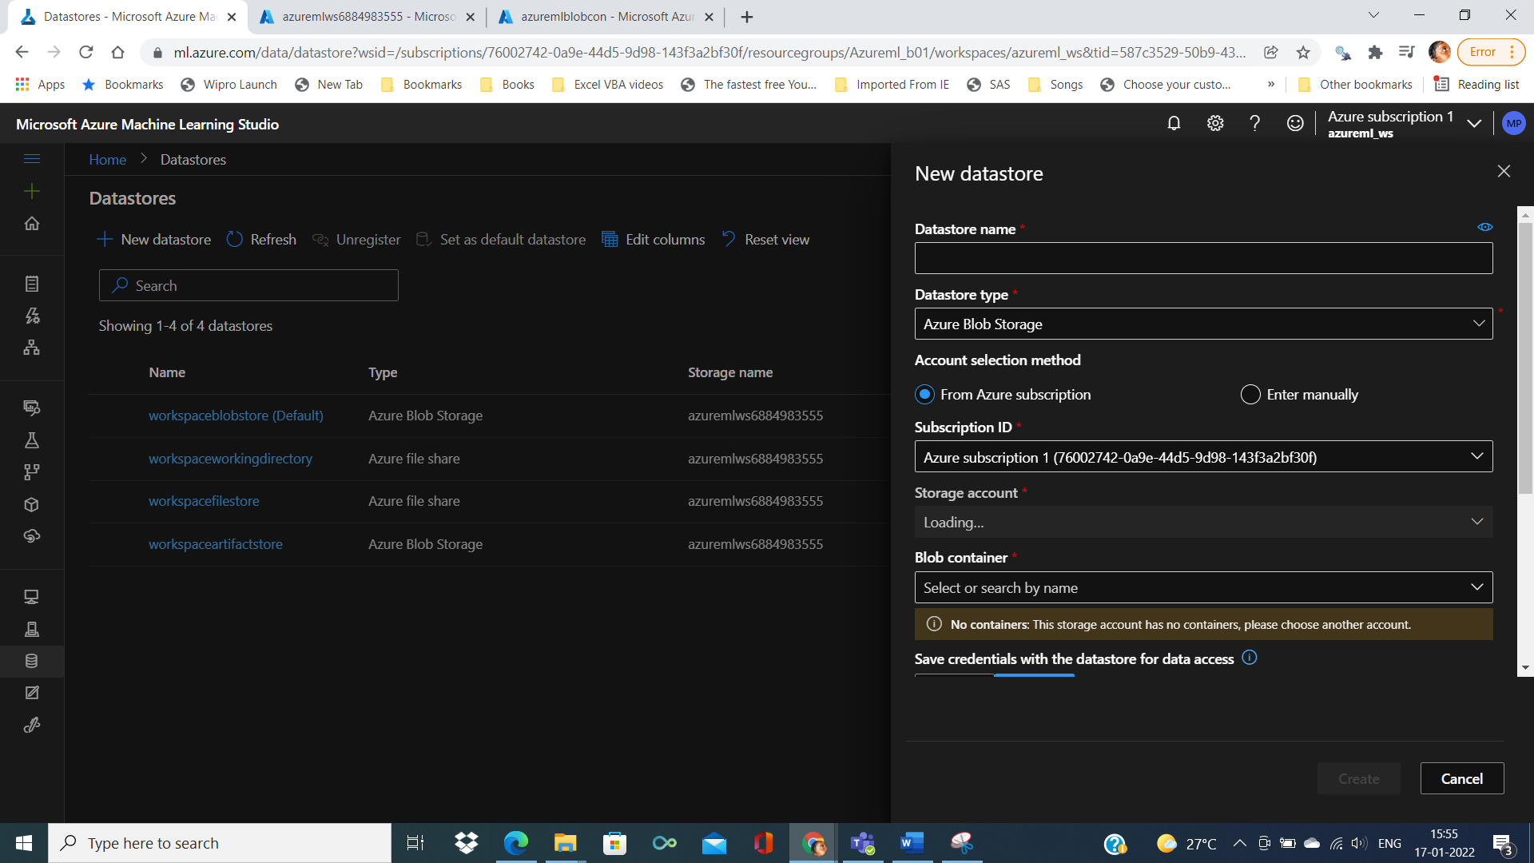

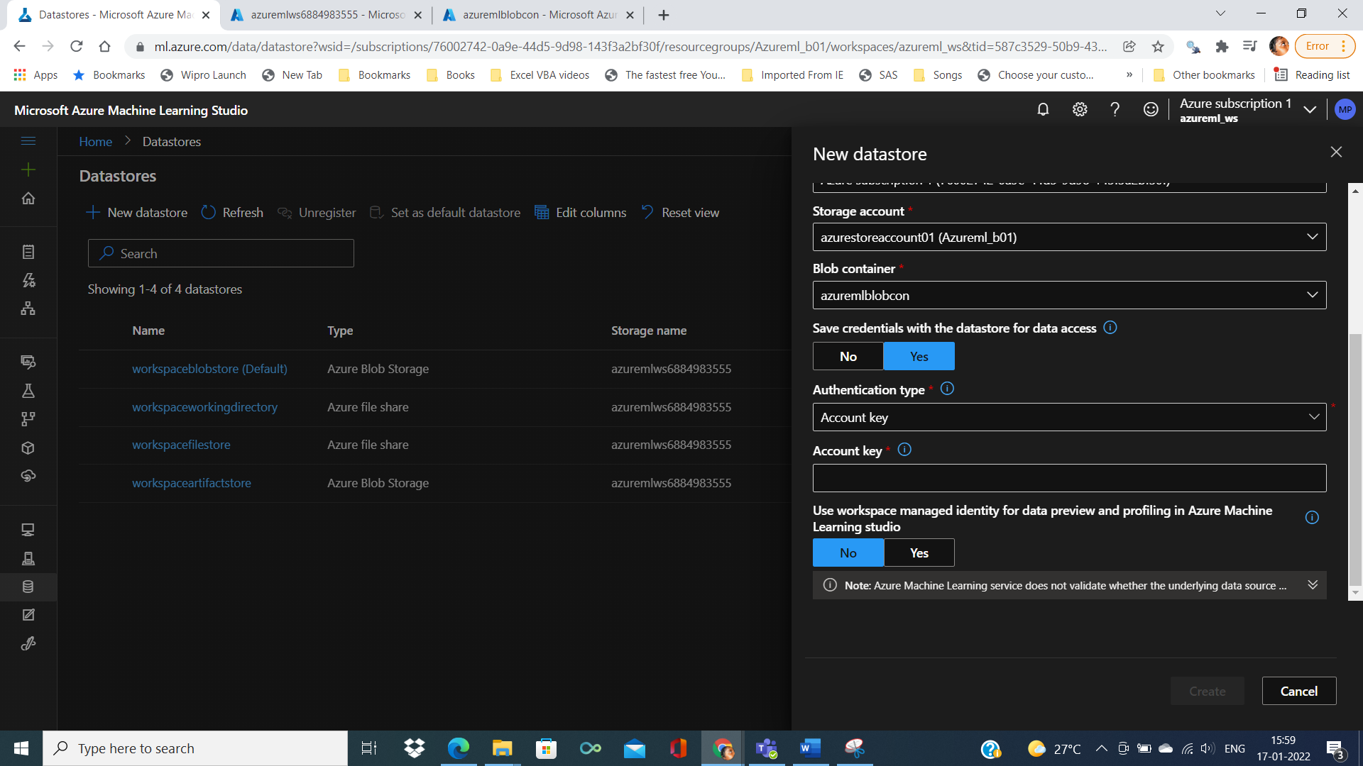

Account key need to be taken from storage account

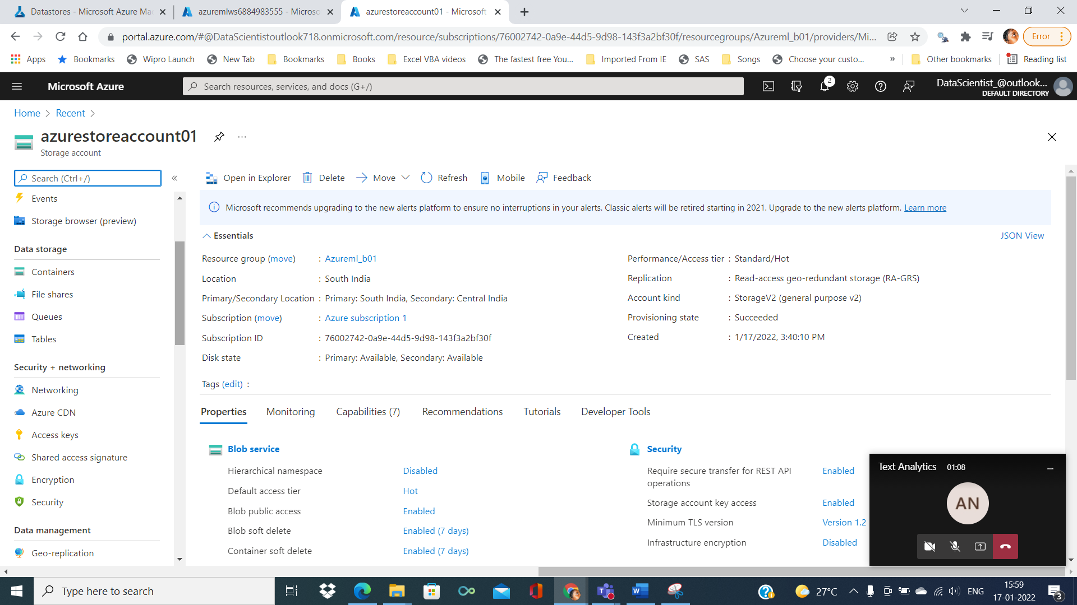

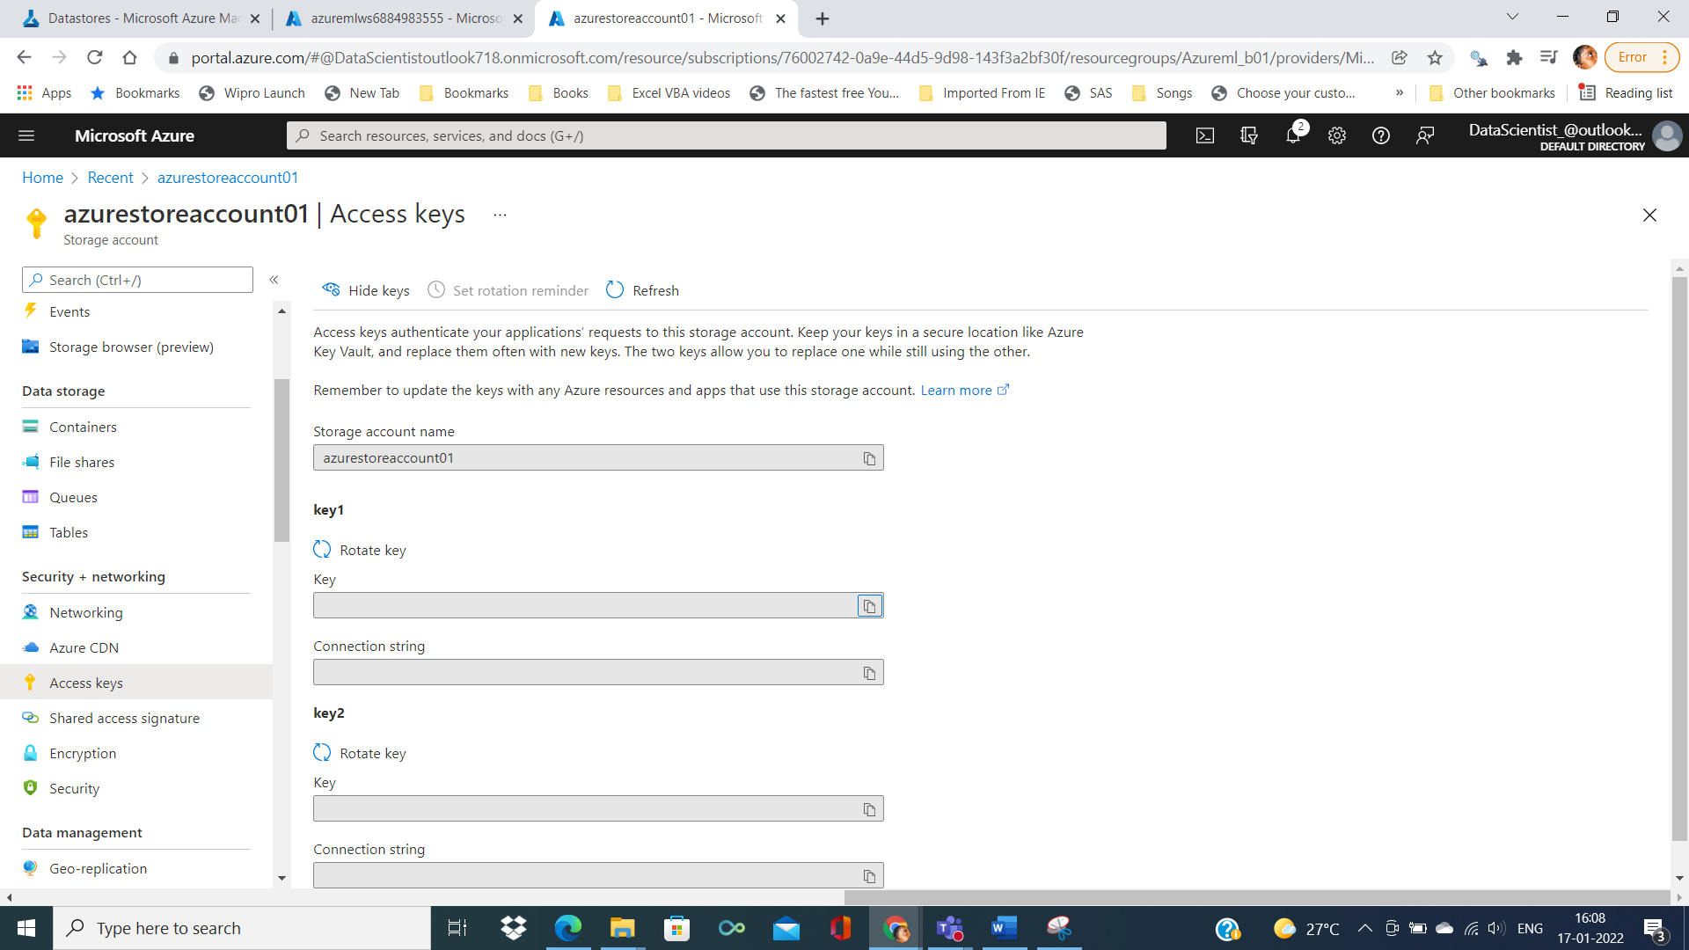

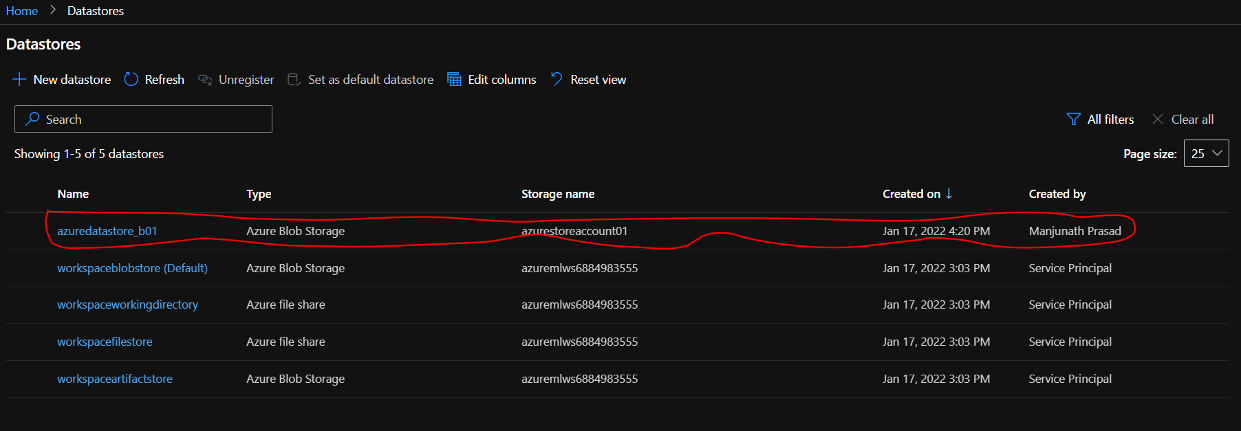

By clicking the azureblob storage and clicking on Azuremlblob

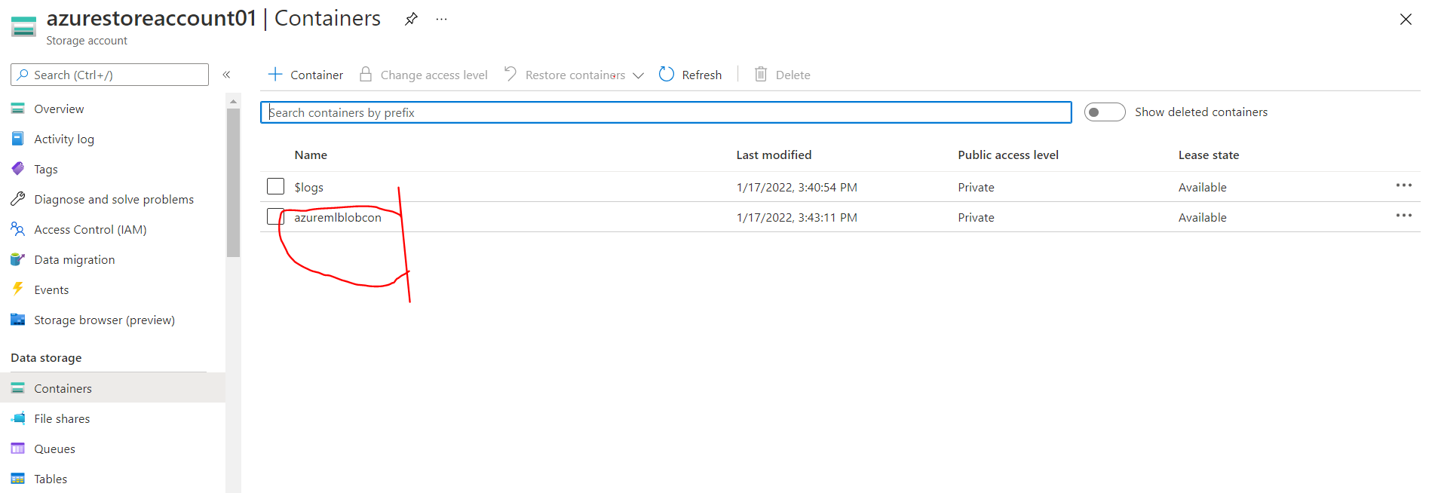

File can be uploaded using ‘upload button’

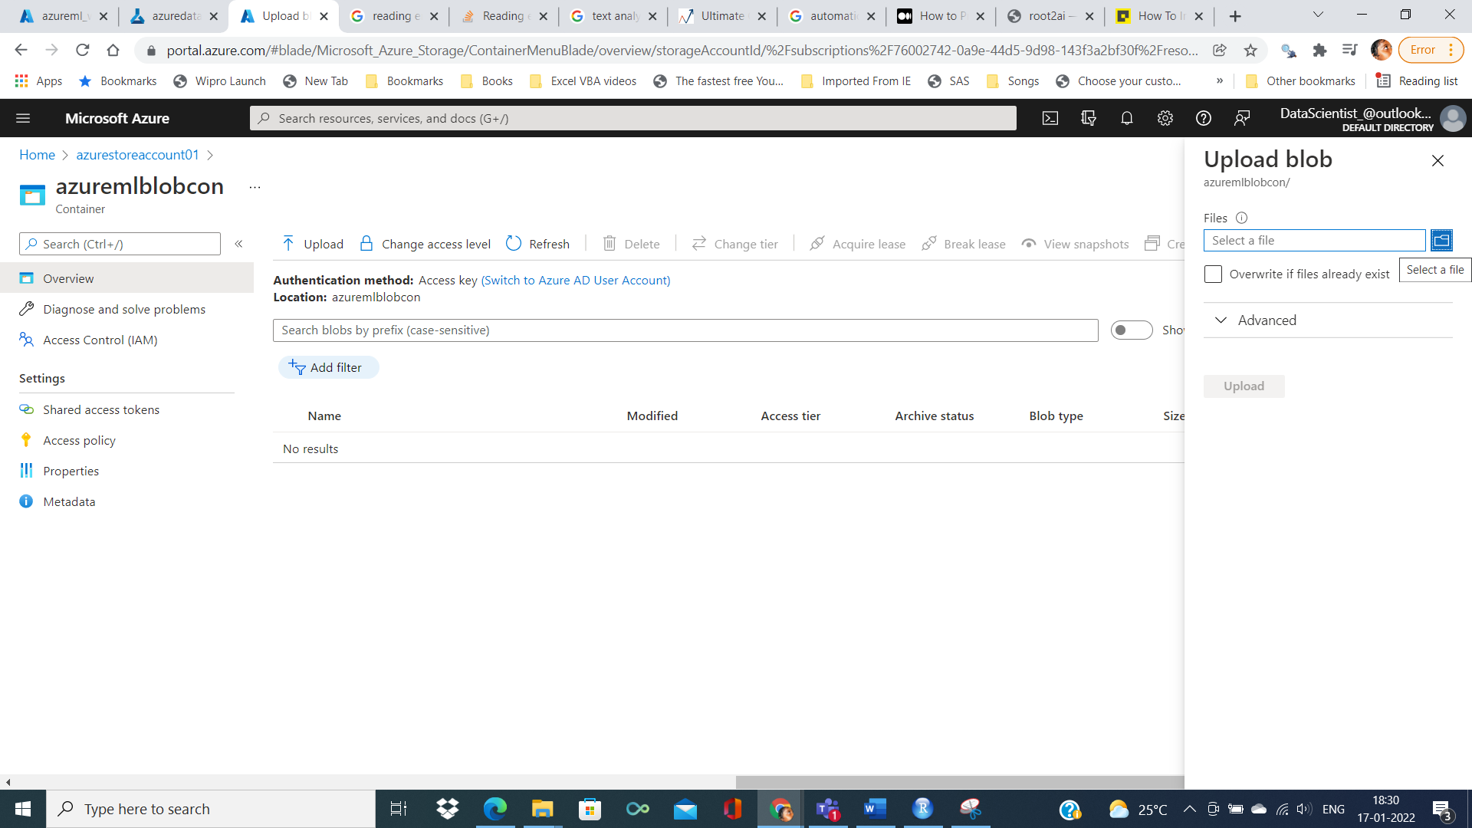

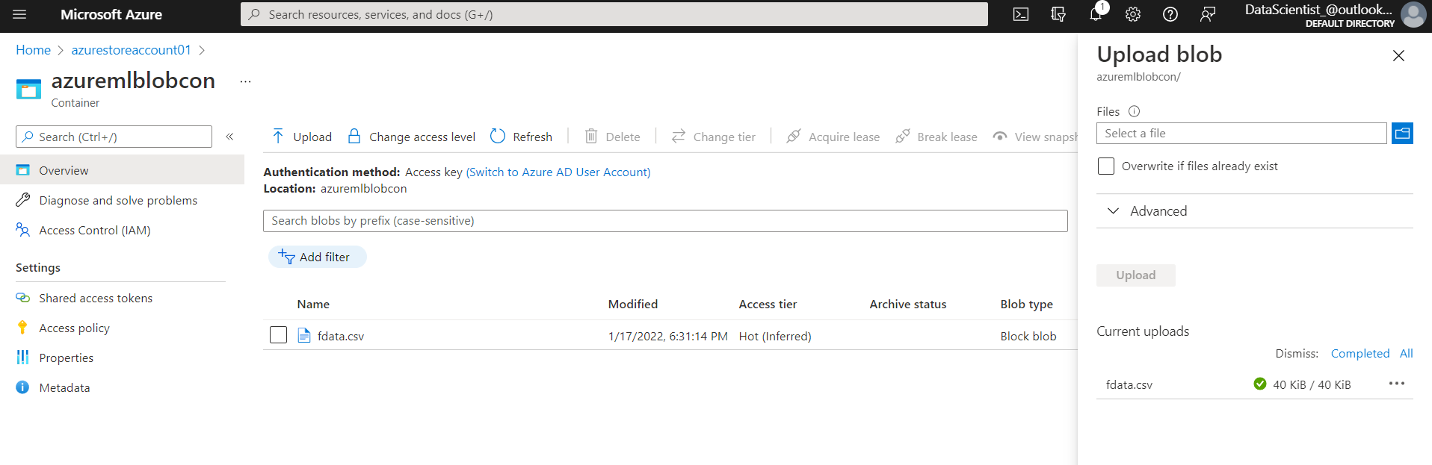

But to load the multiple files we can uploading using storage browser in previous tab

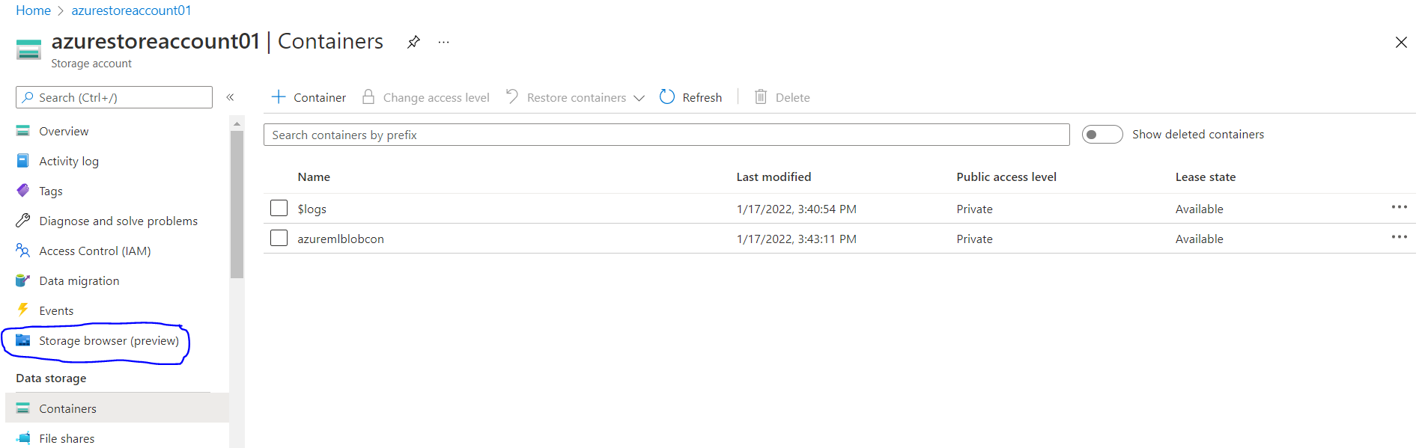

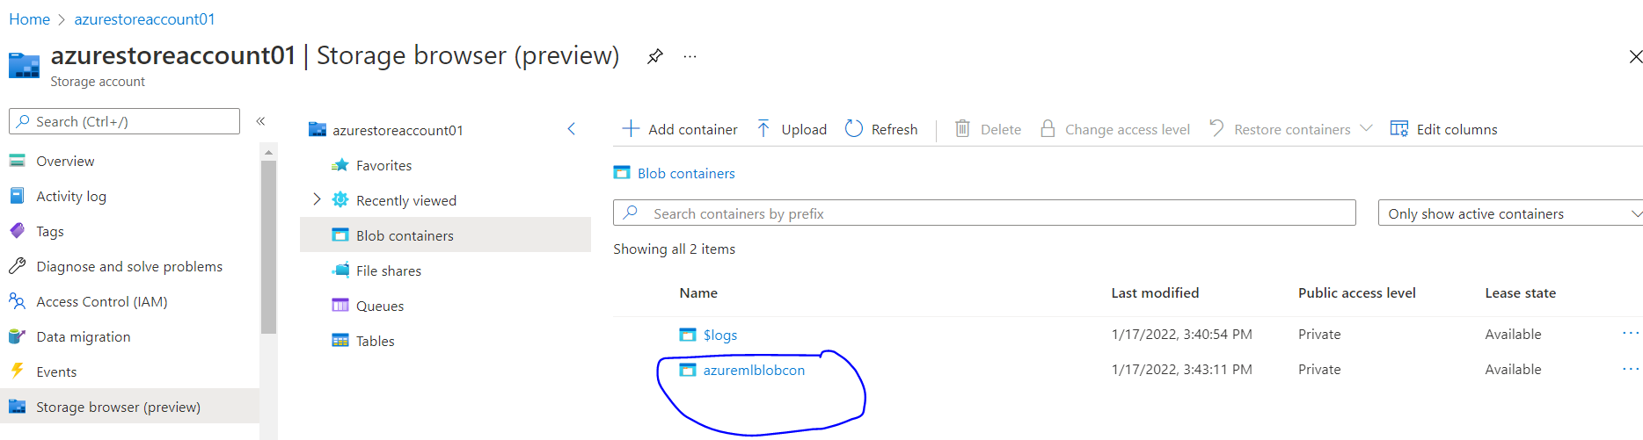

Two files were uploaded

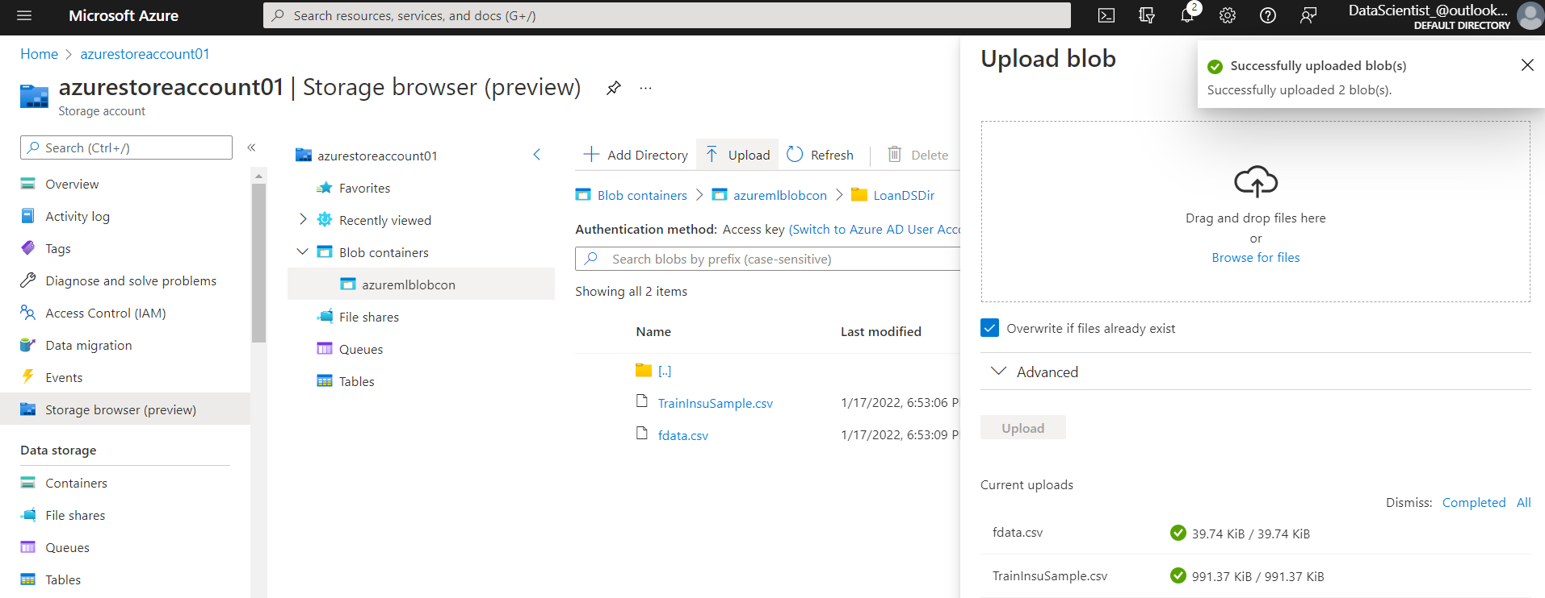

From the previous process , containers were created and mounted to the folder with datafile

Now we’ll creating dataset from azure studio

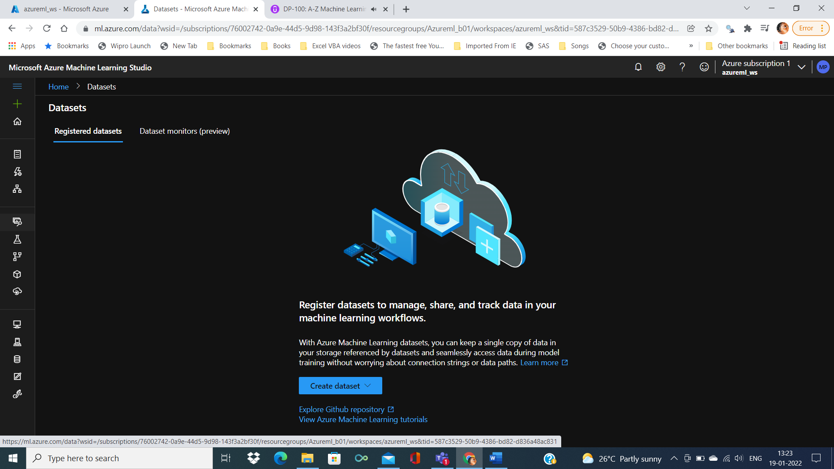

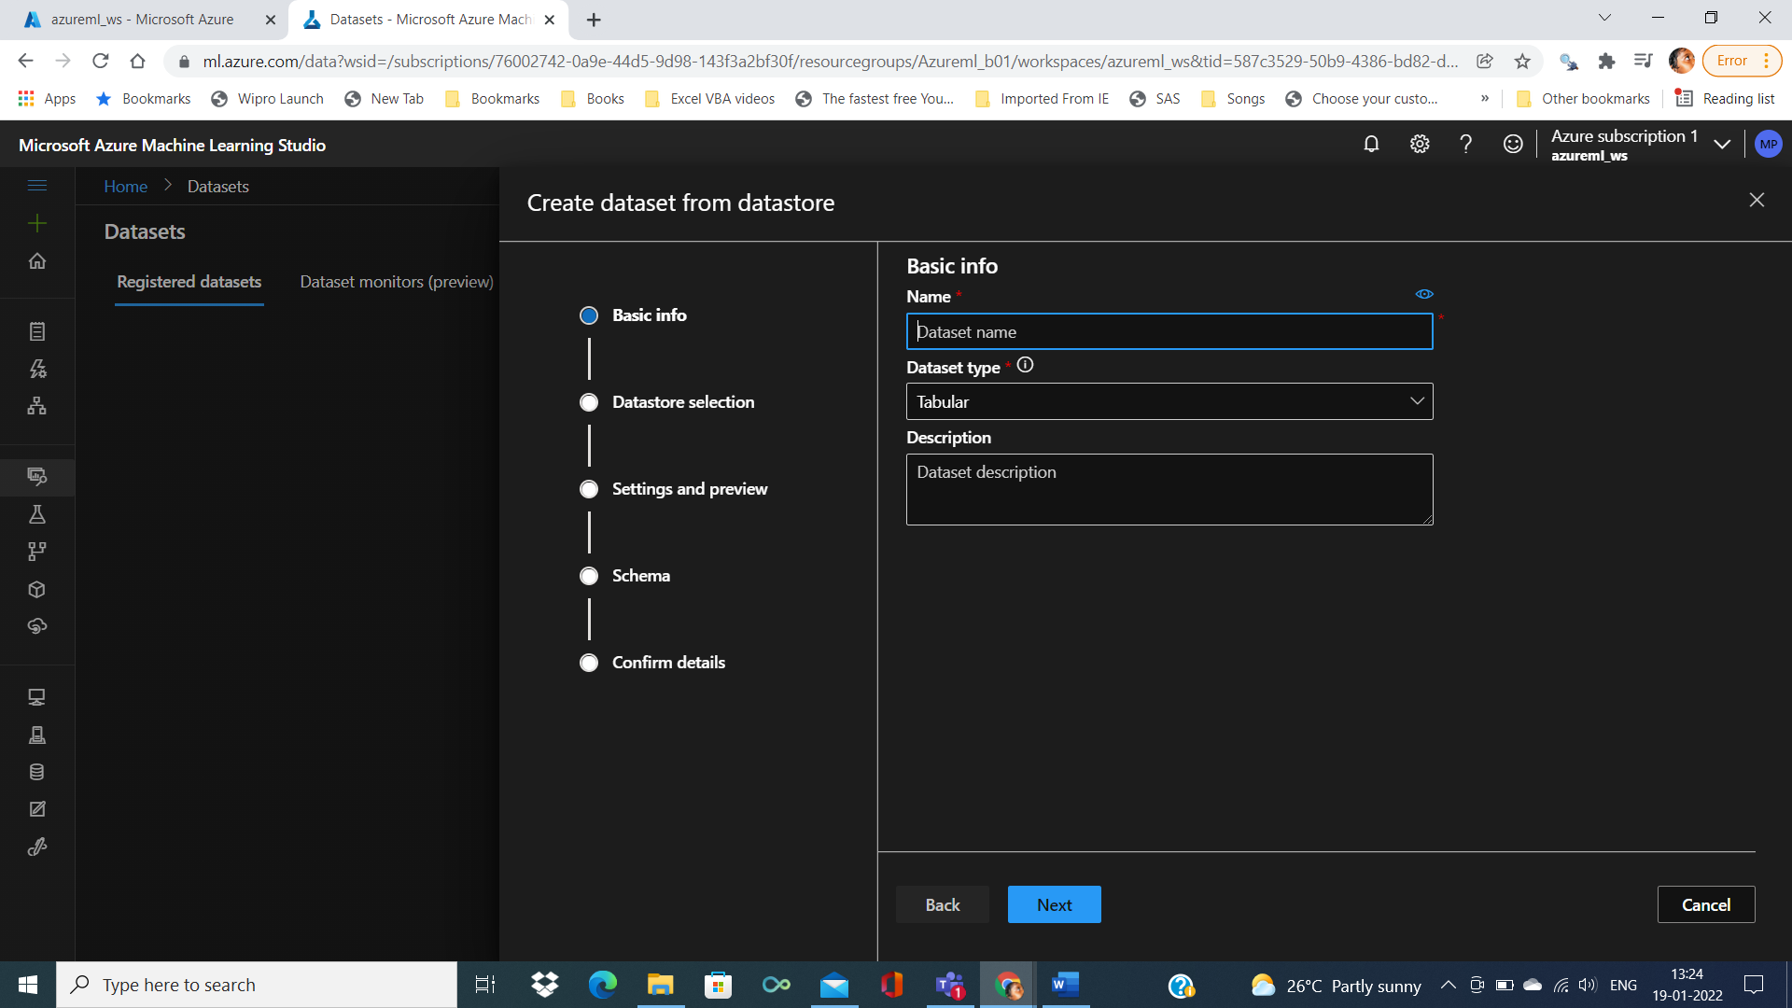

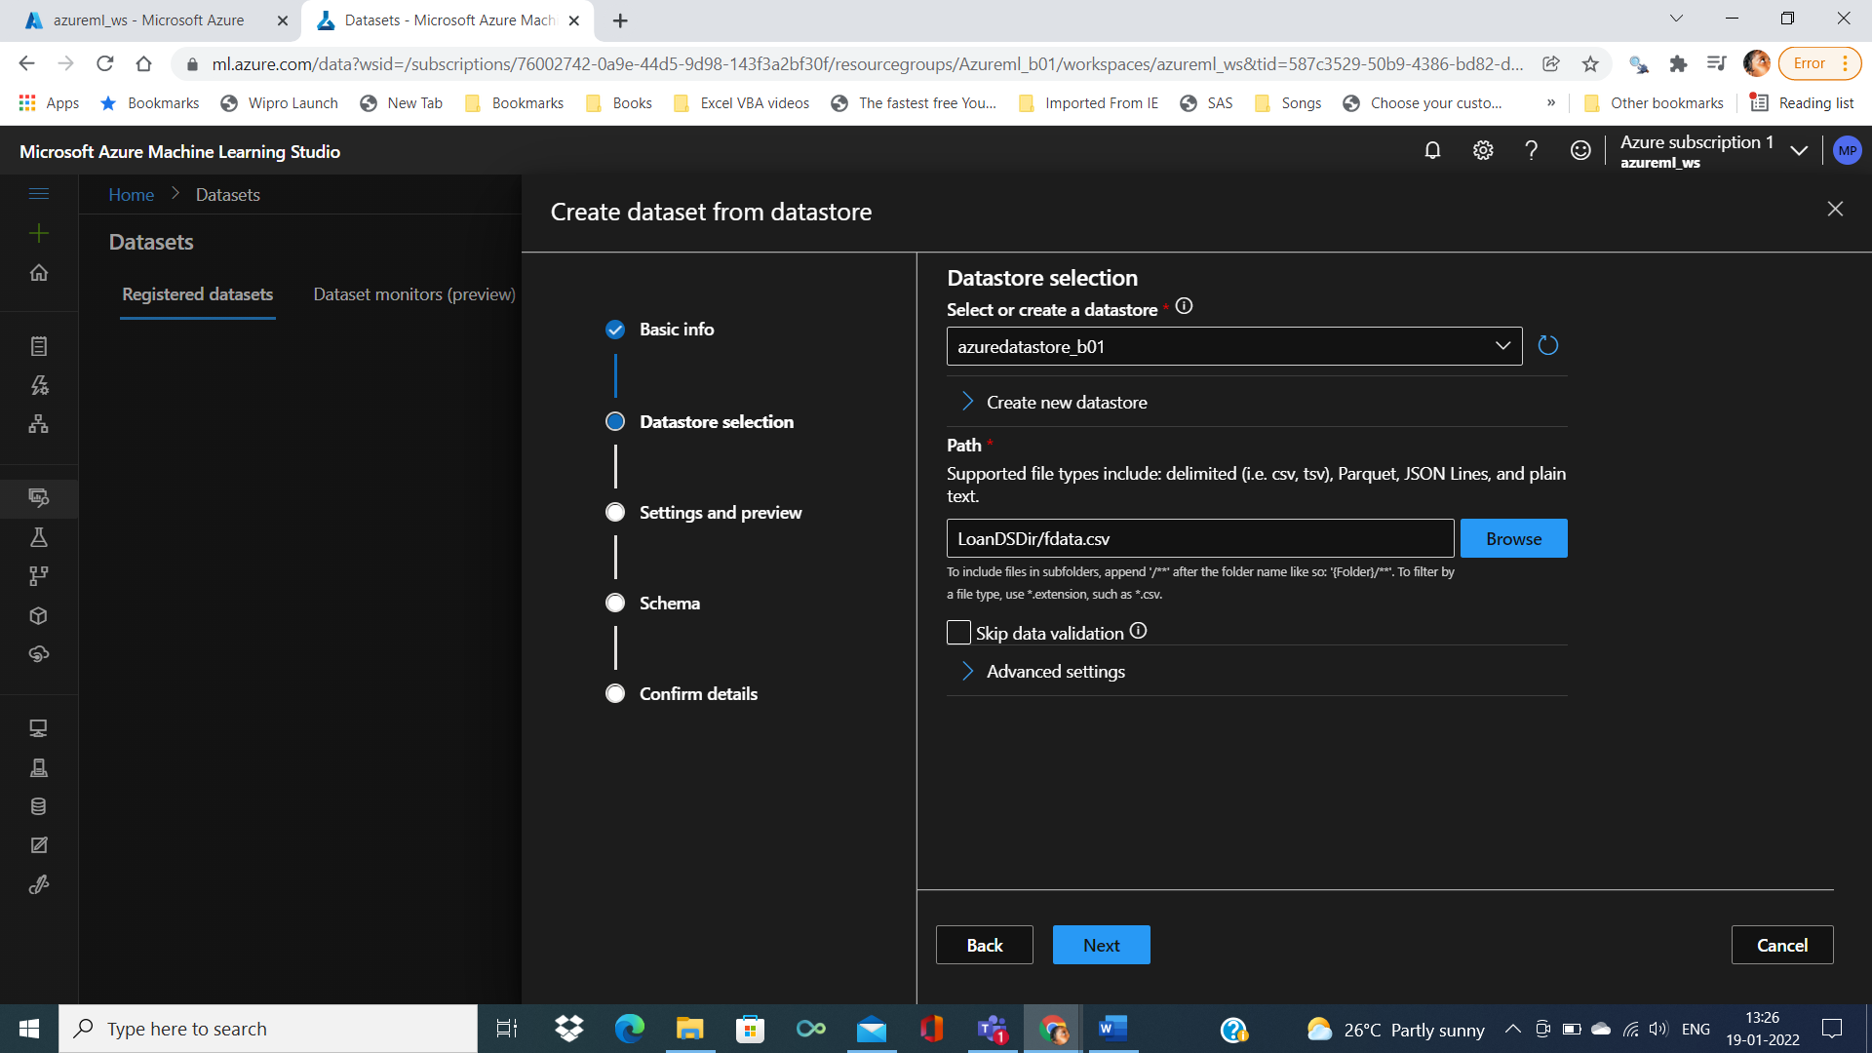

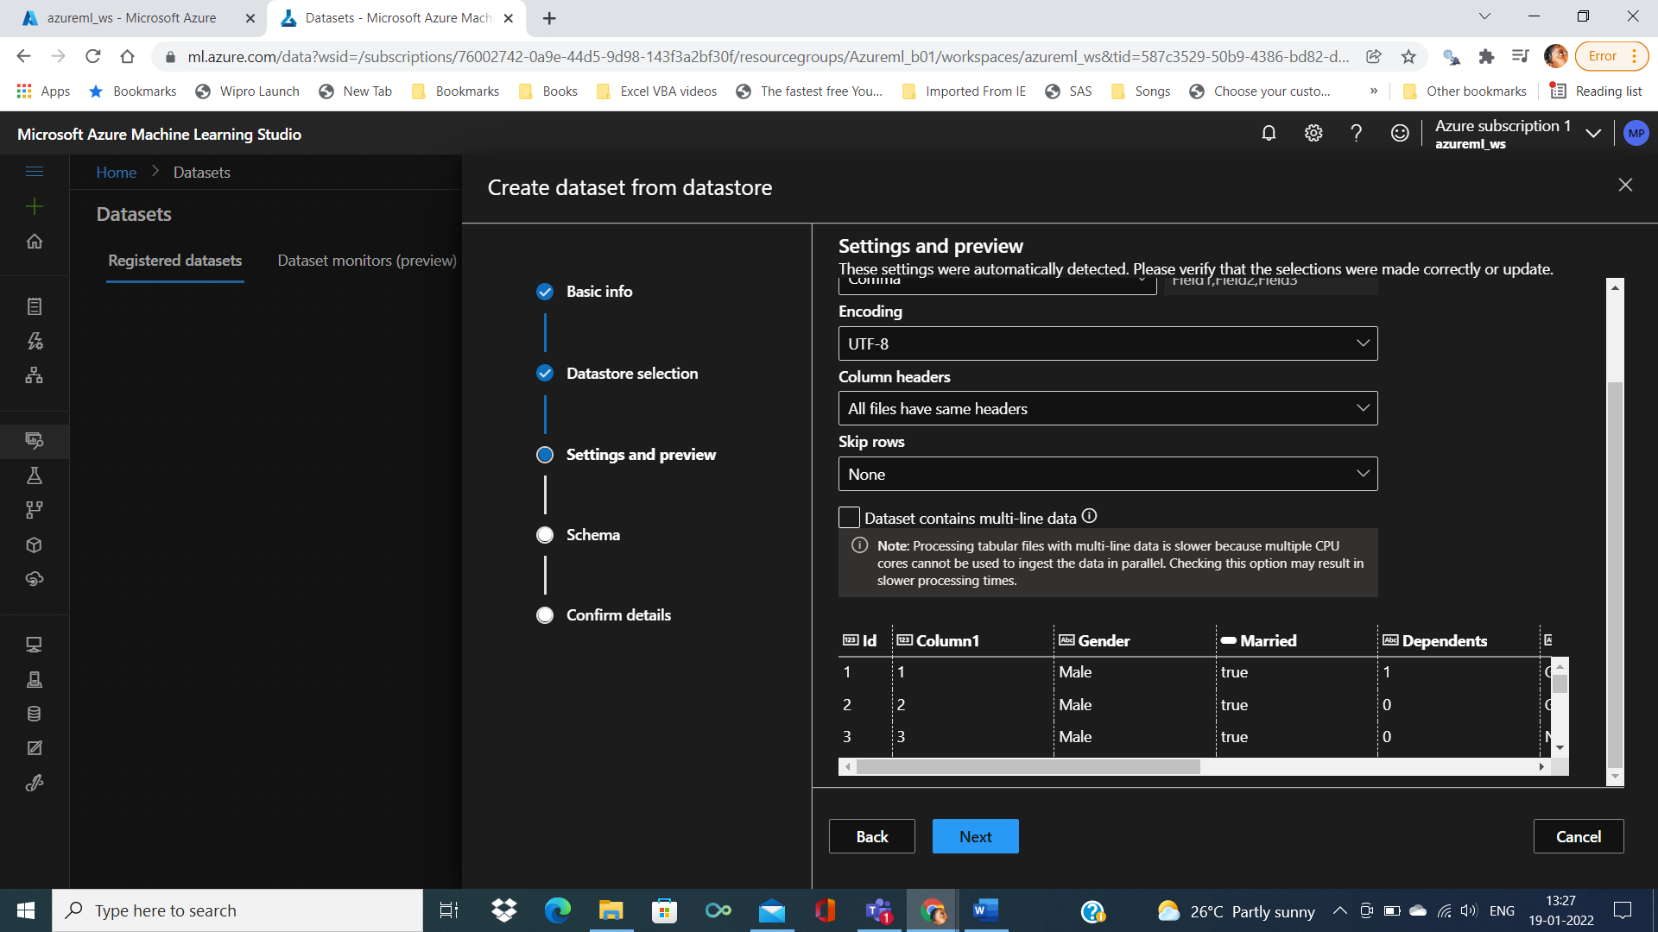

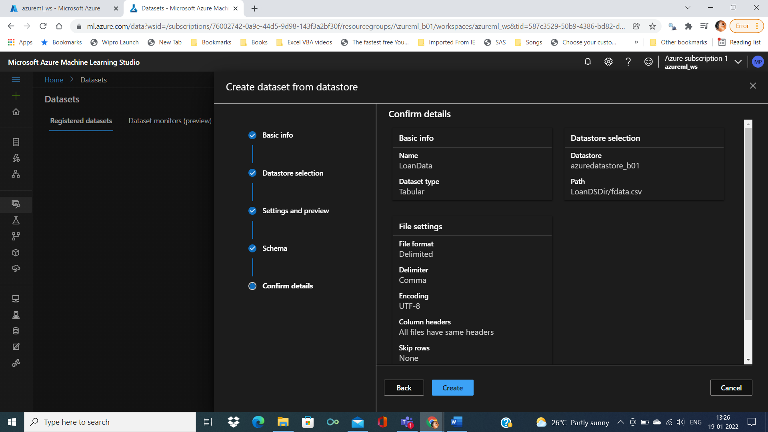

Click on create to complet the process of creating dataset from within AzureStudio

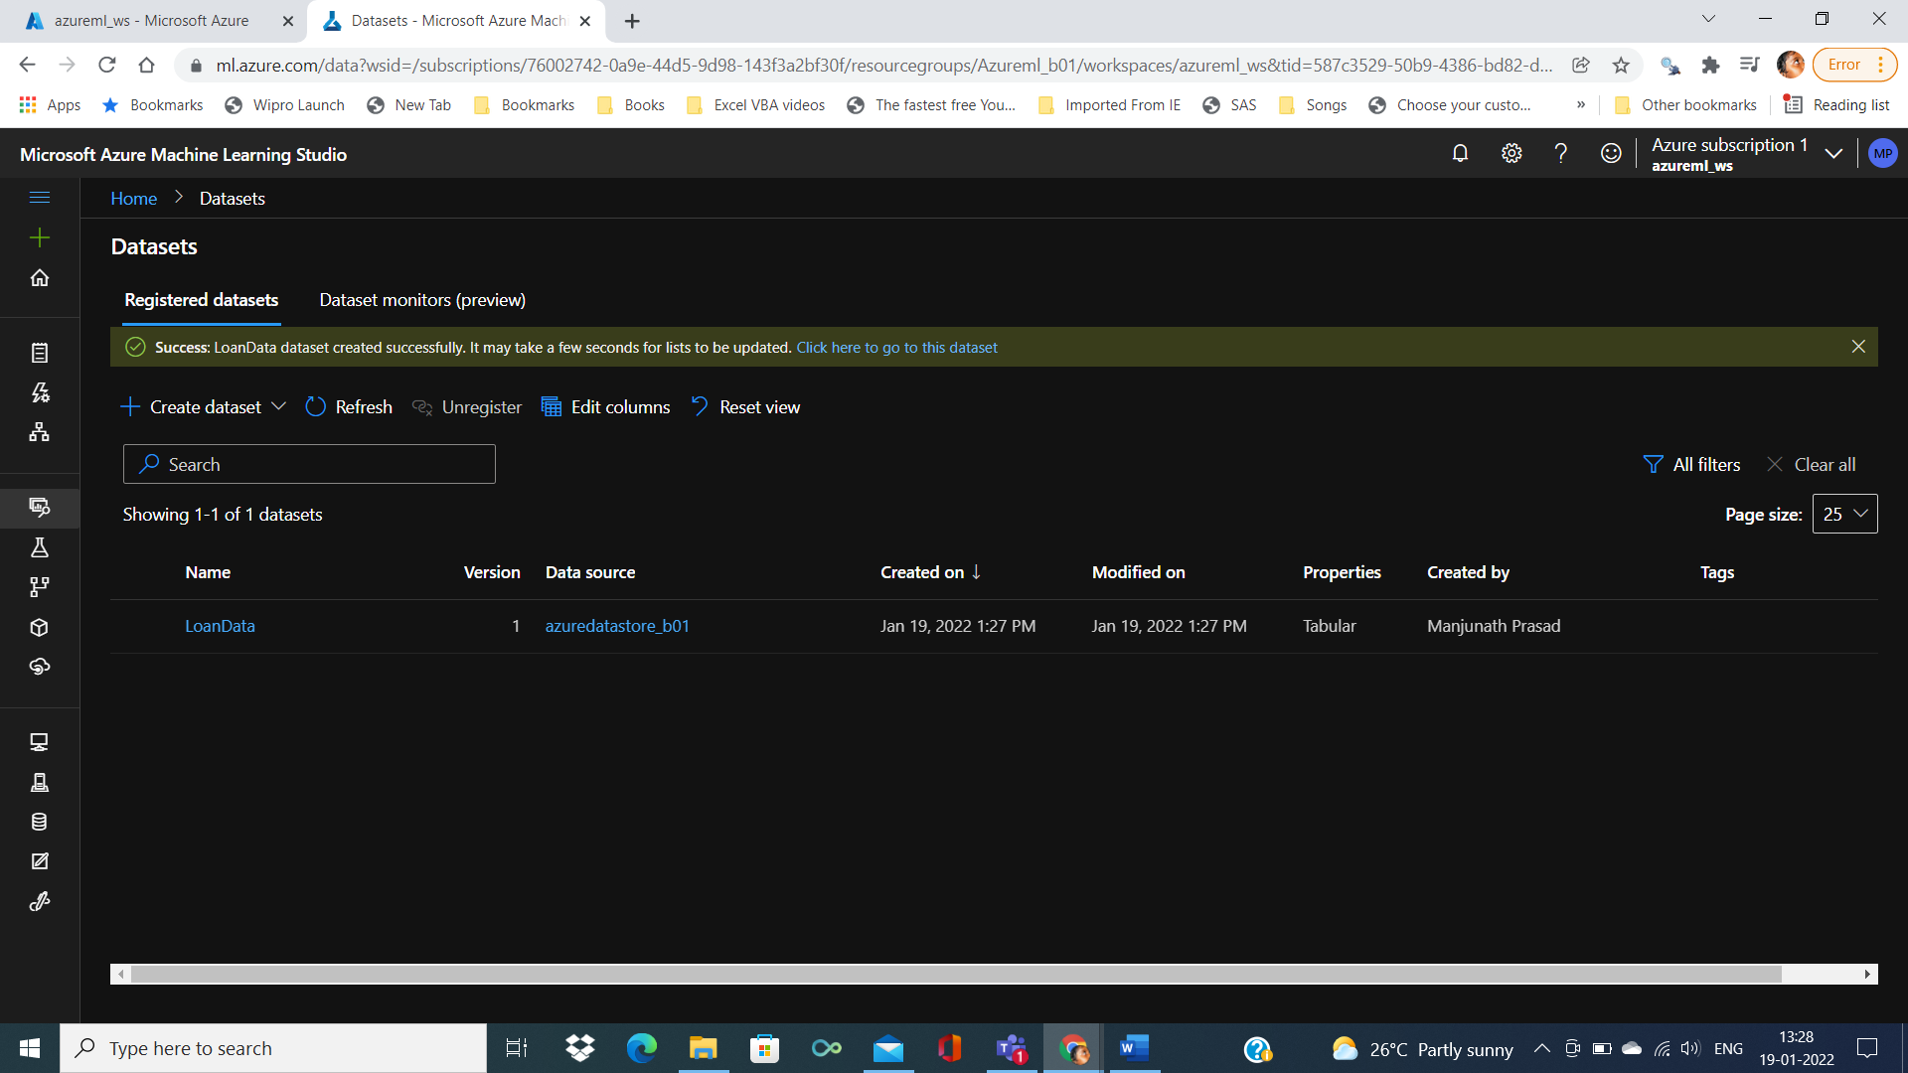

By double clicking on loandata, we can able to see the details, Exploration (summary info)

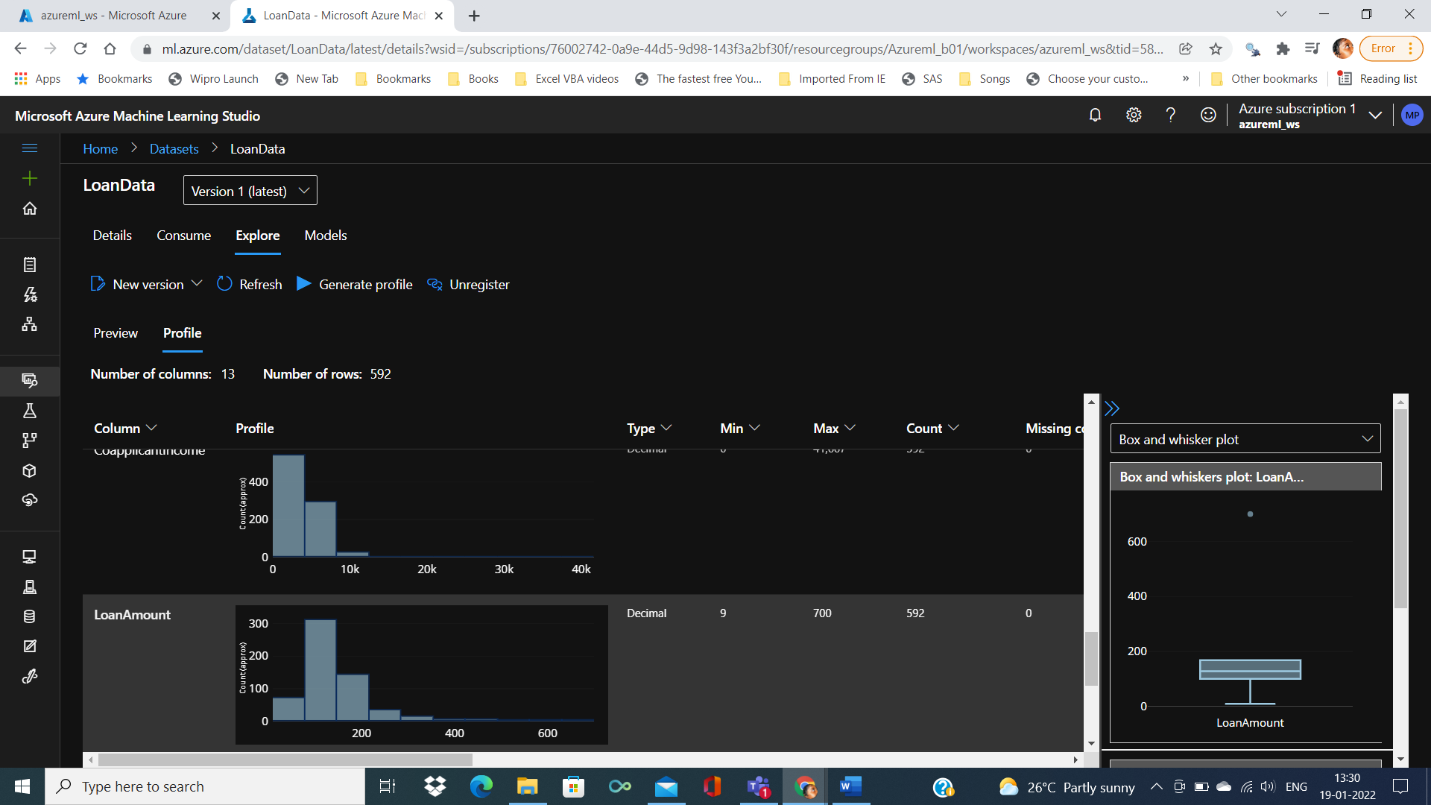

Creating Compute Instance and Cluster

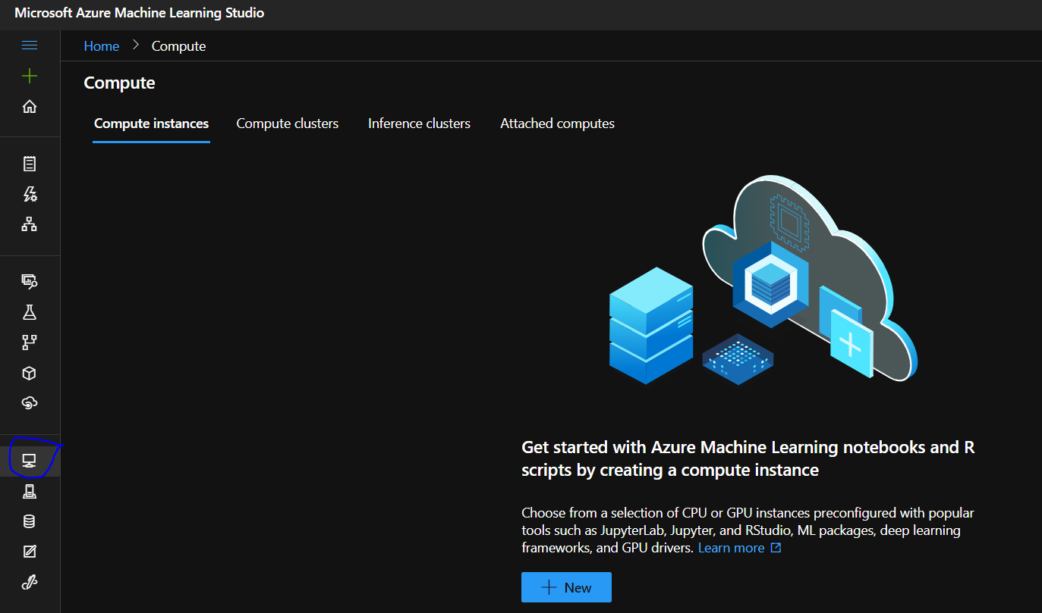

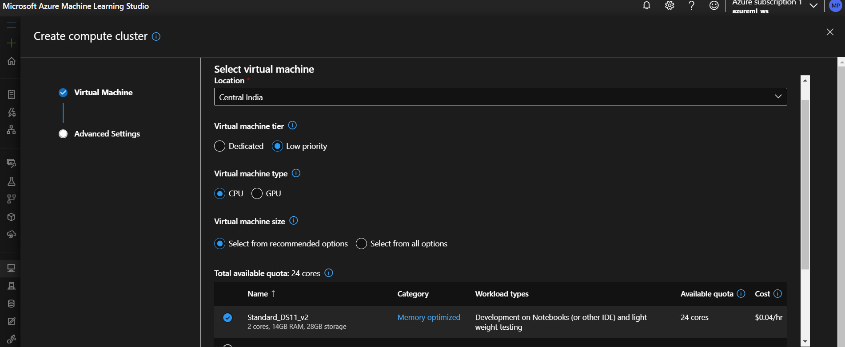

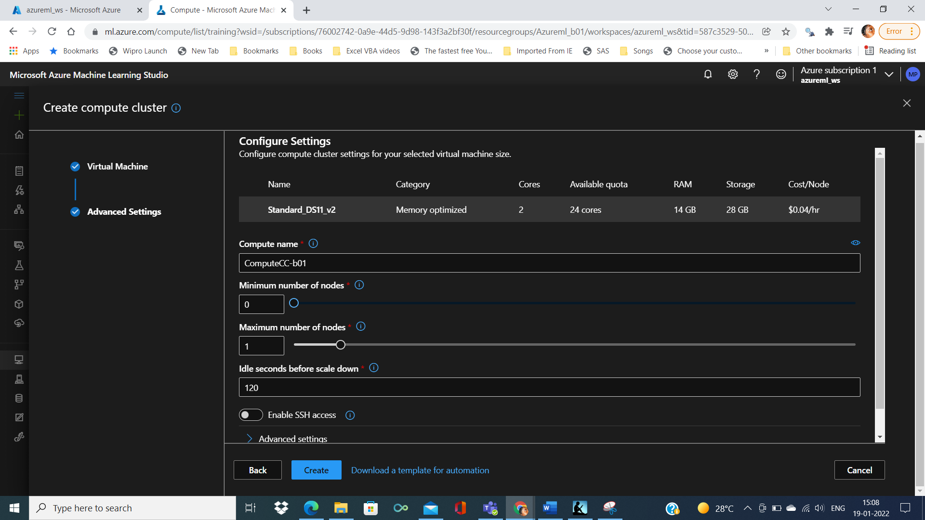

Finally Compute cluster is created

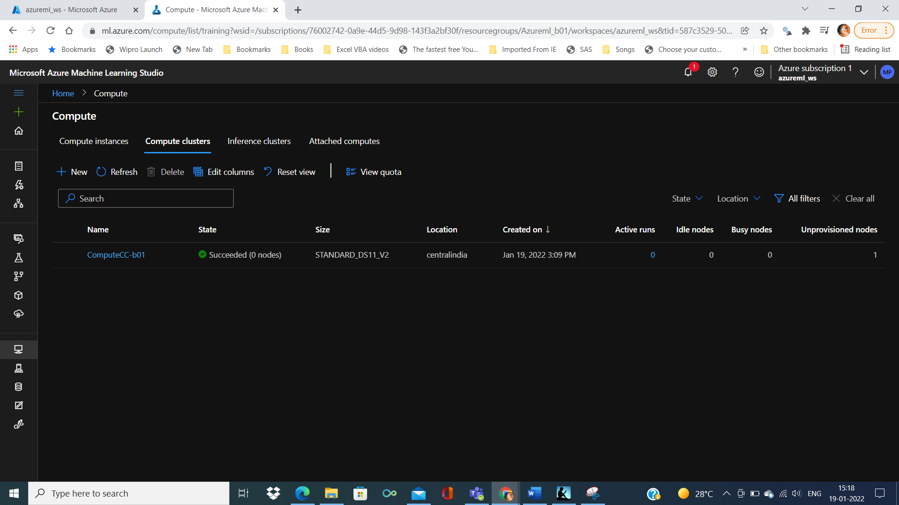

Similarly we’ll create computer instance

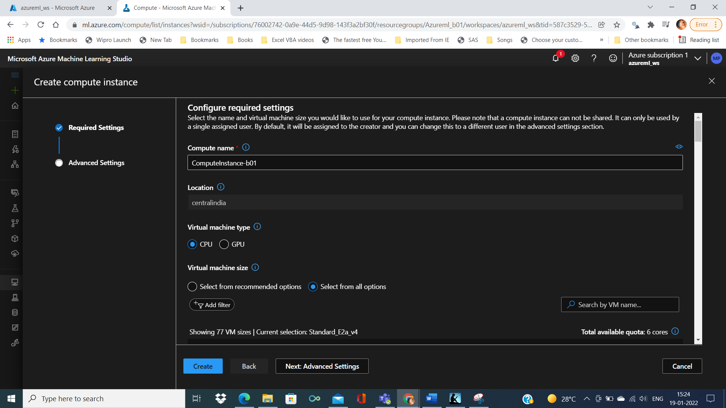

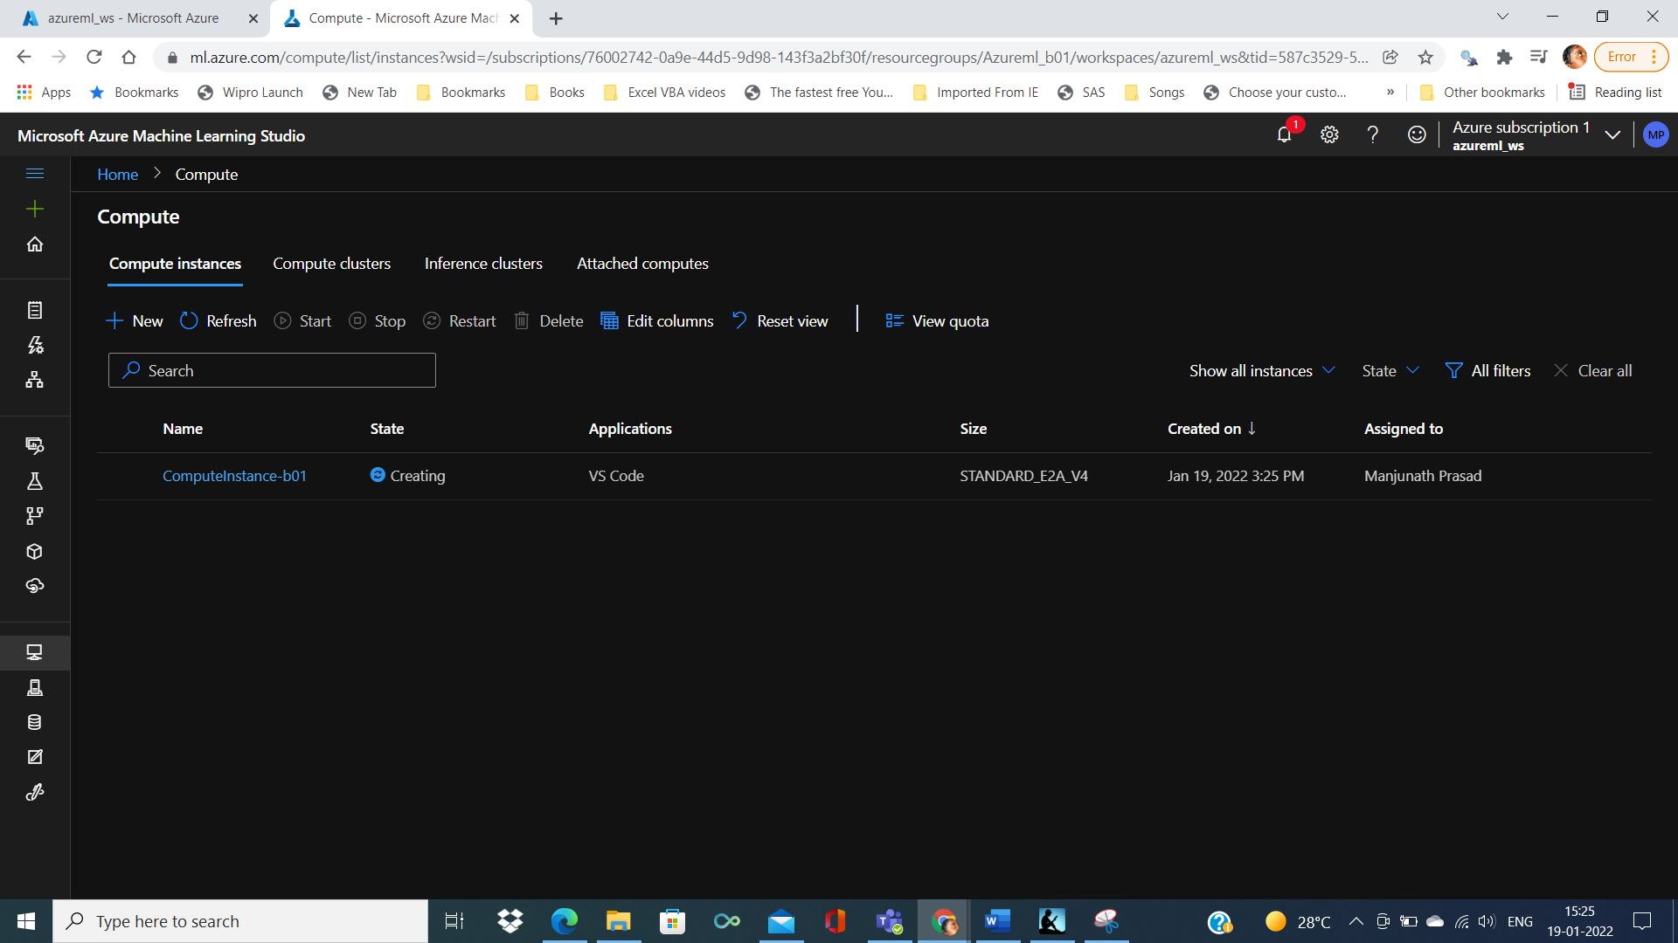

Experiment Pipelines

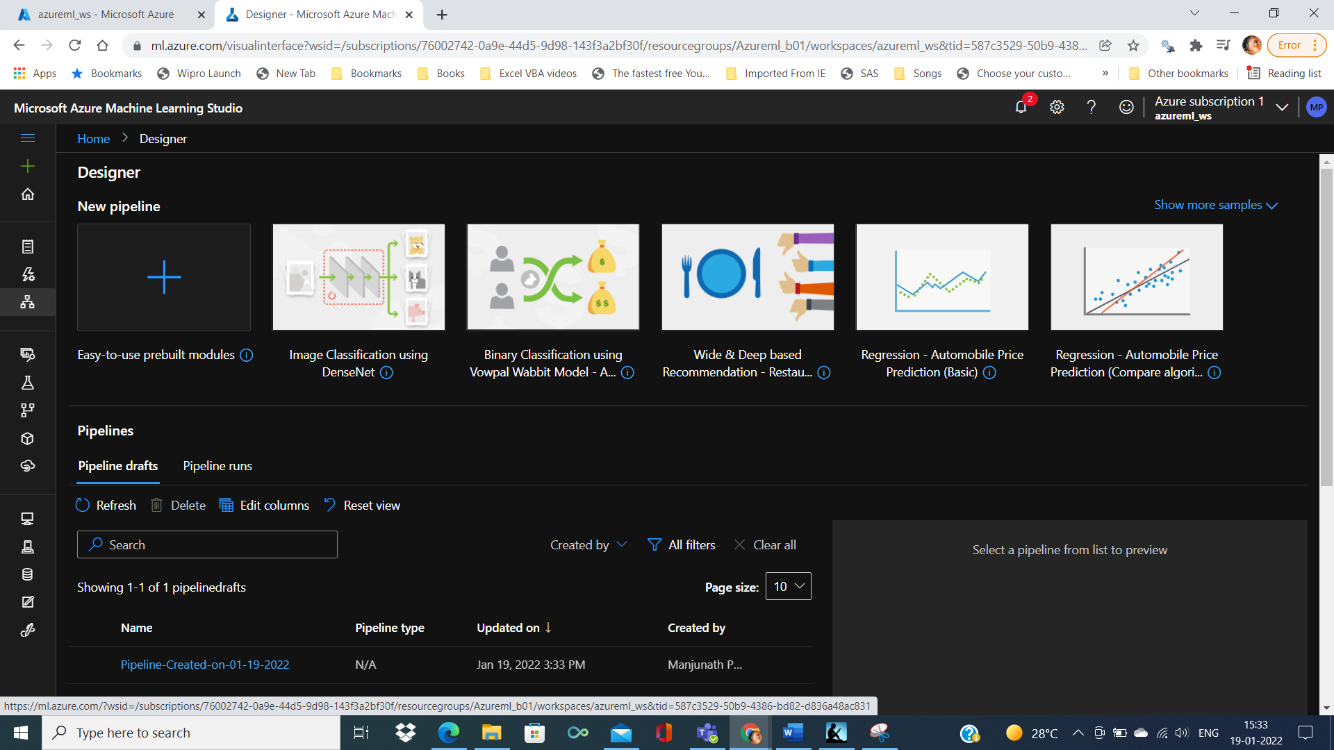

Model deployment

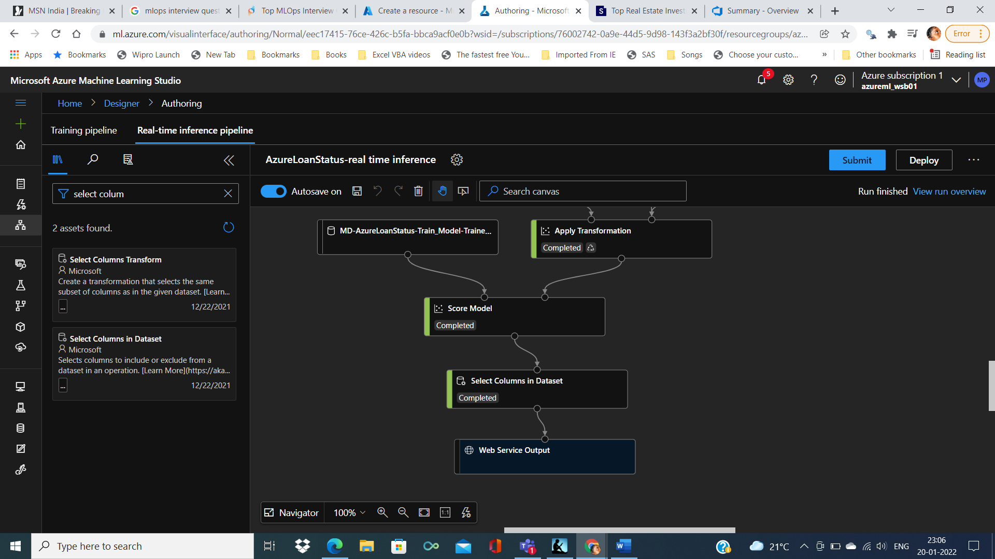

Need to create AKS cluster

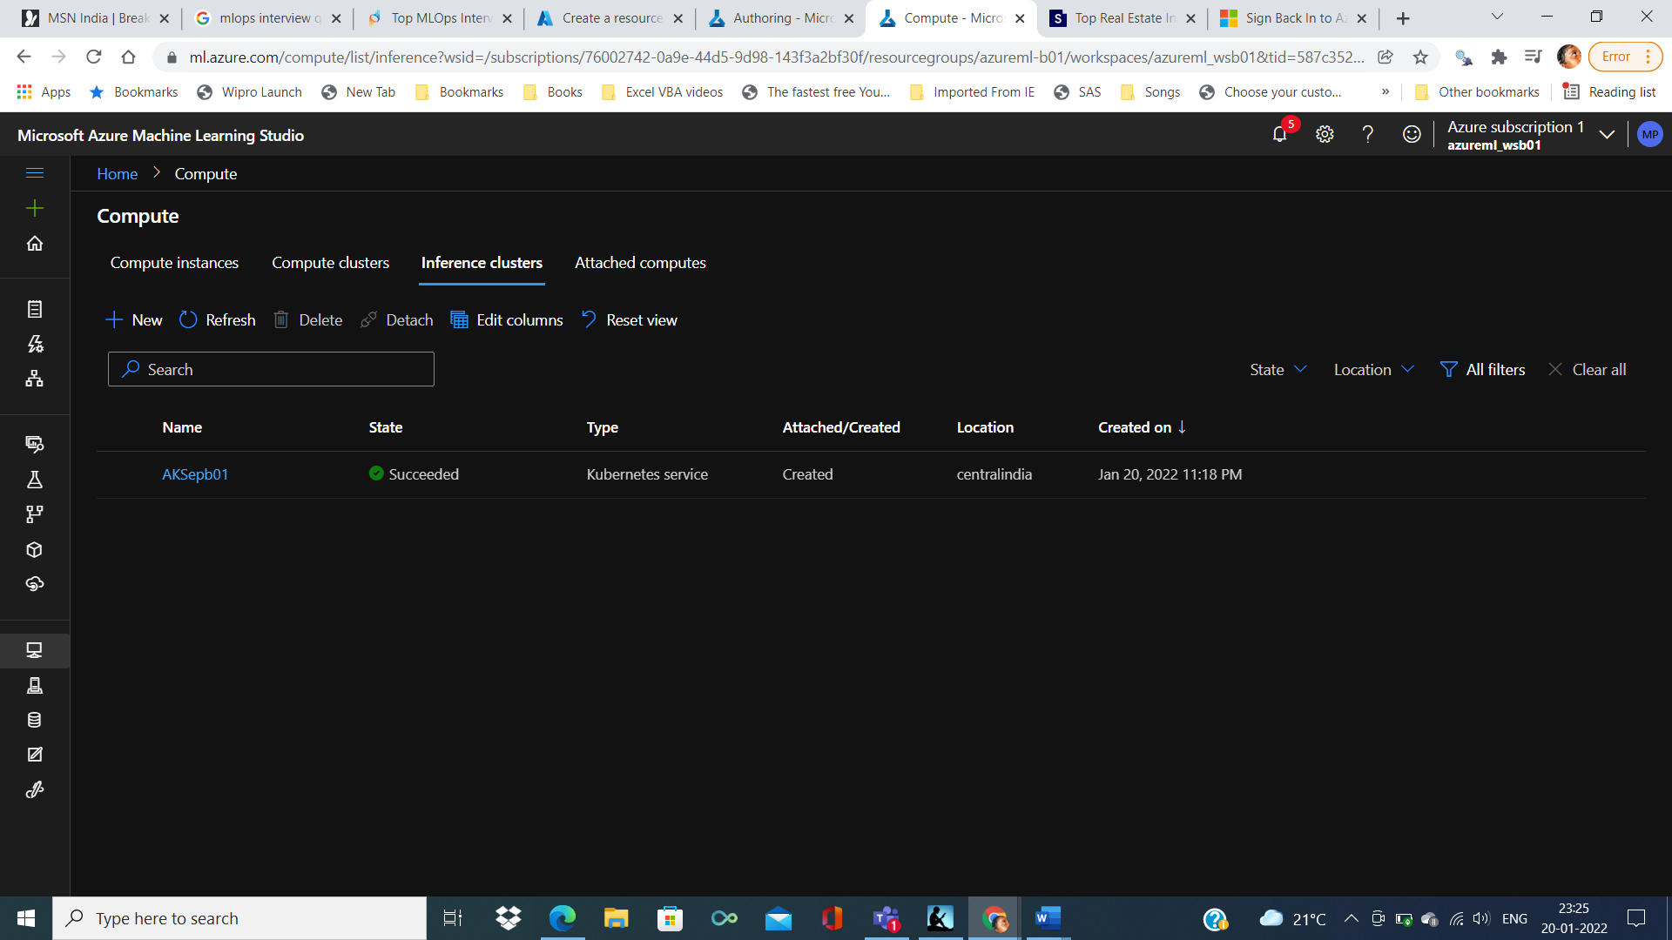

Endpoint deployment

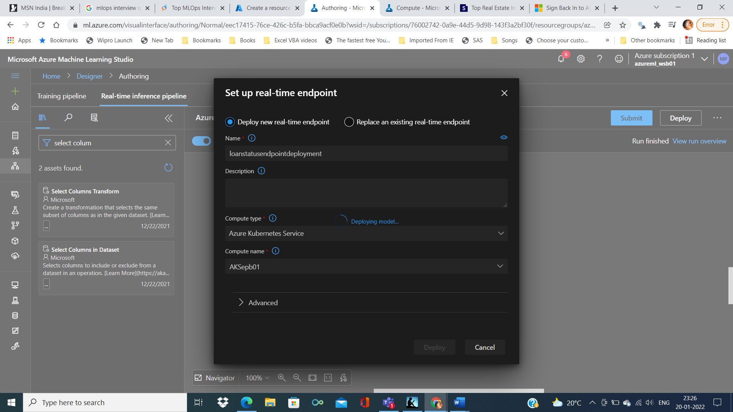

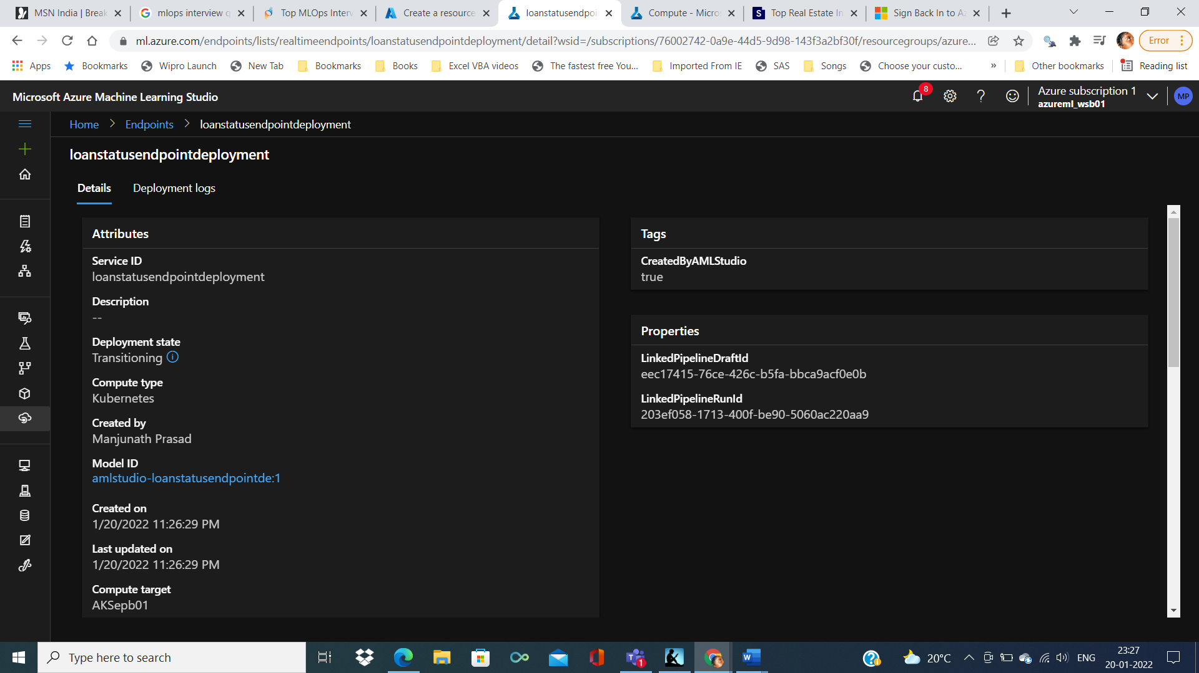

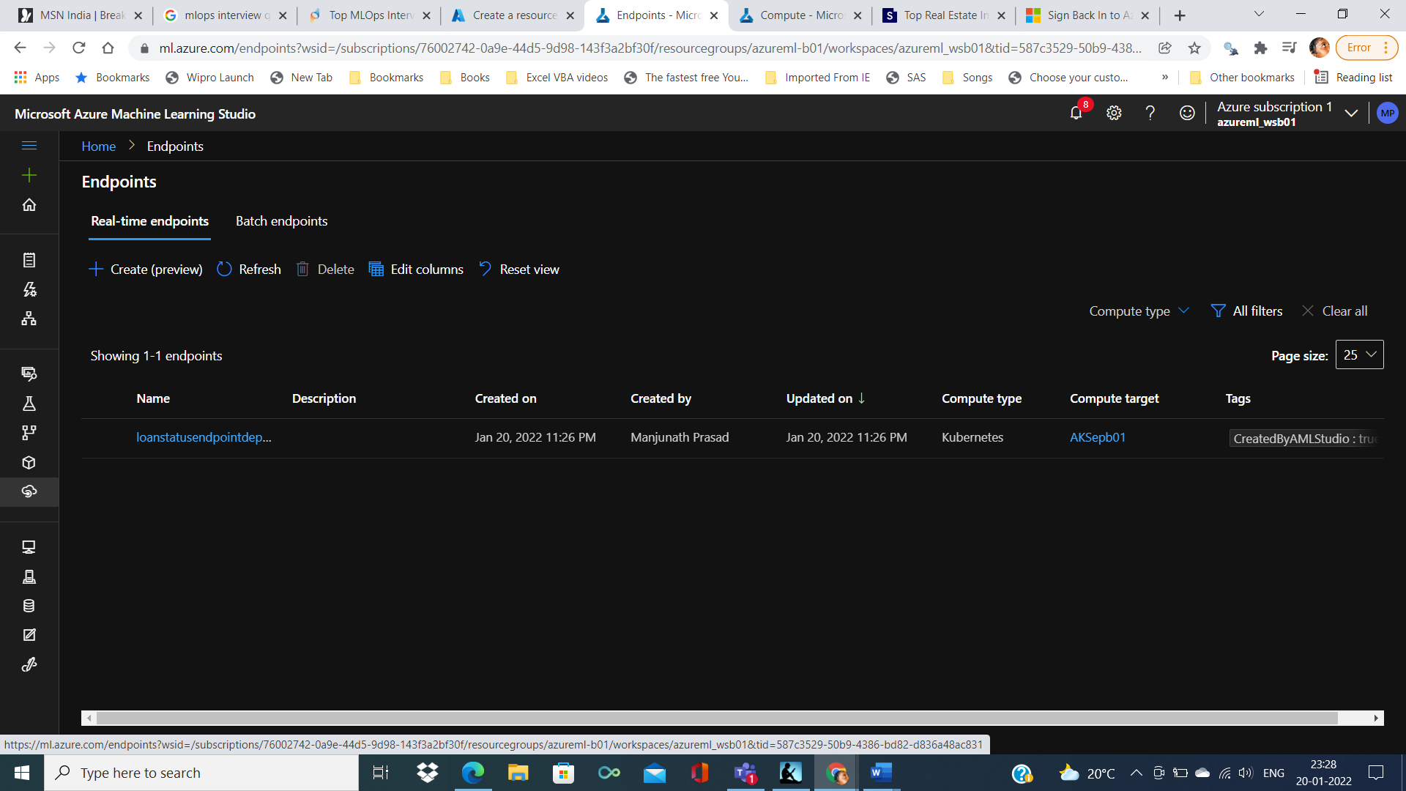

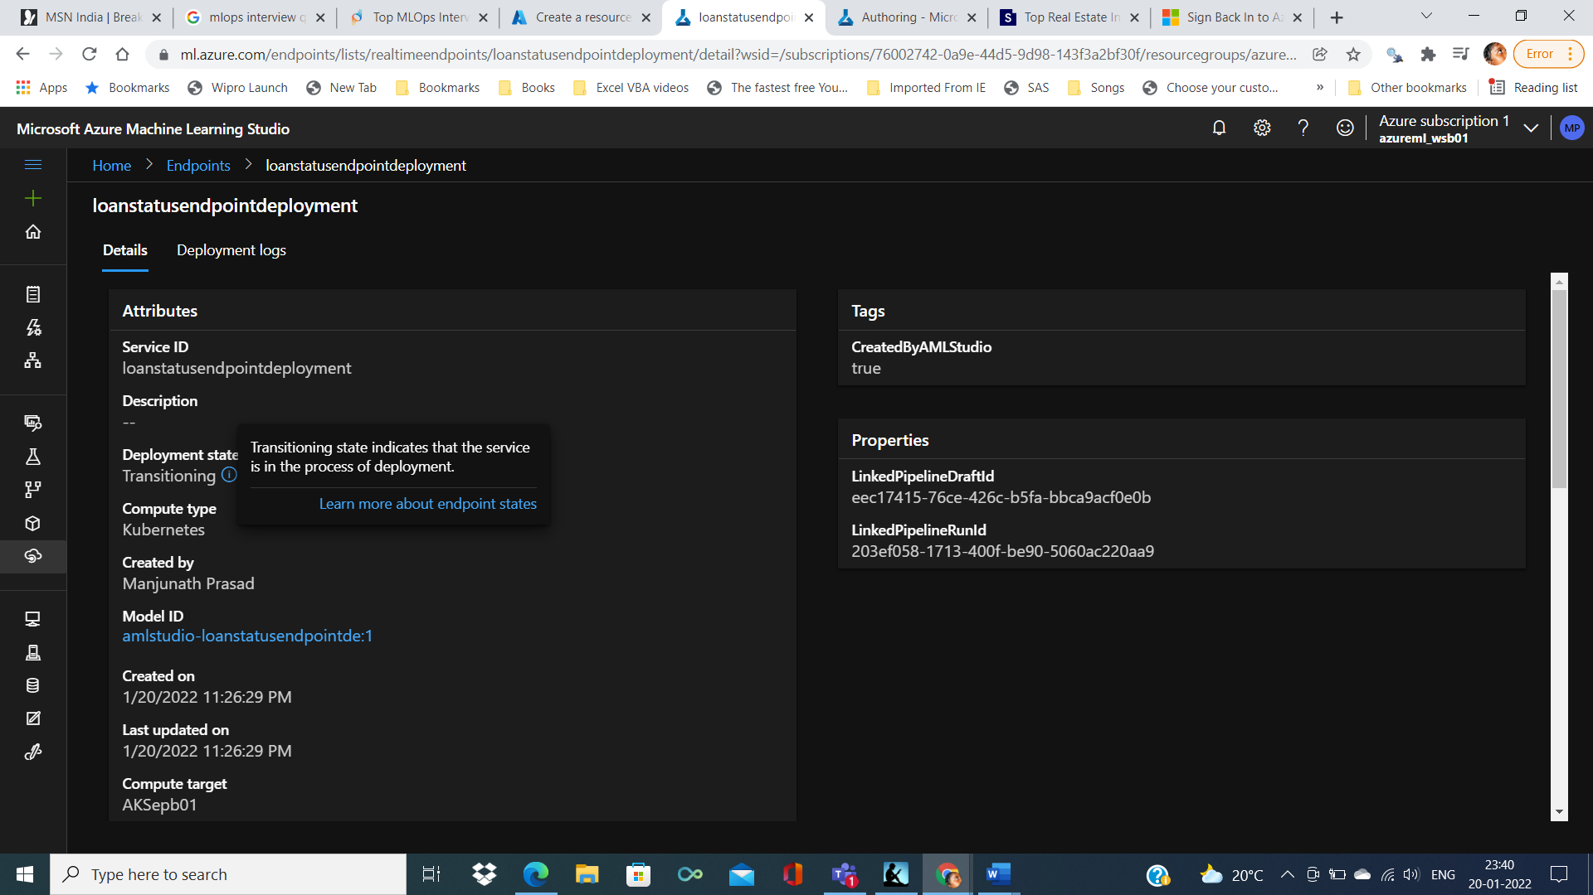

Healthy of deployment

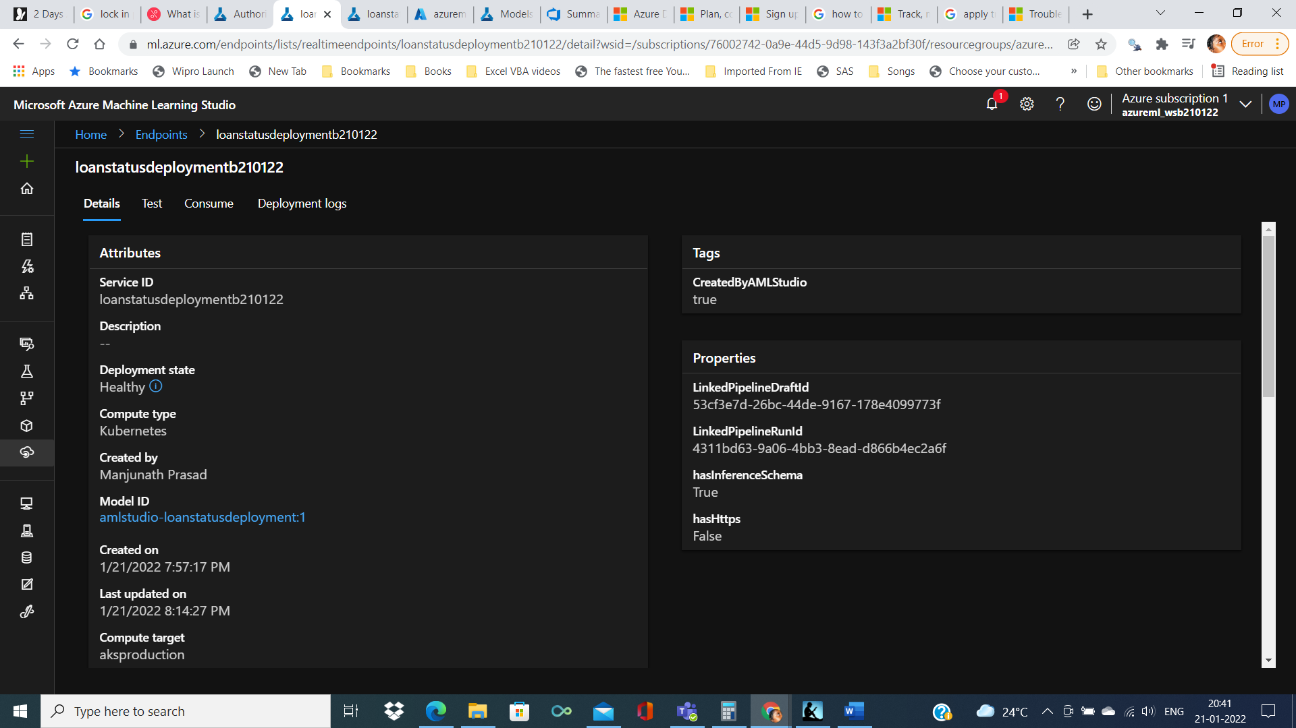

Model can be test with random values

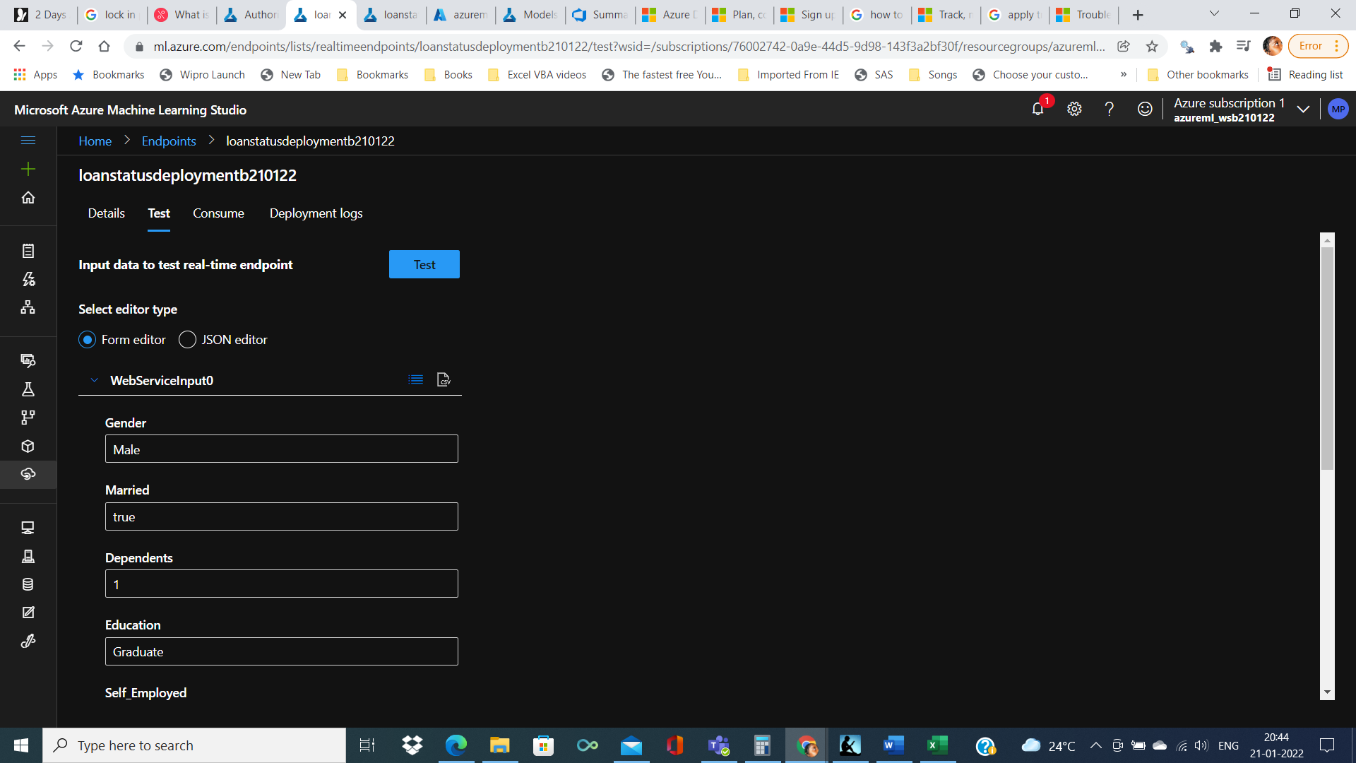

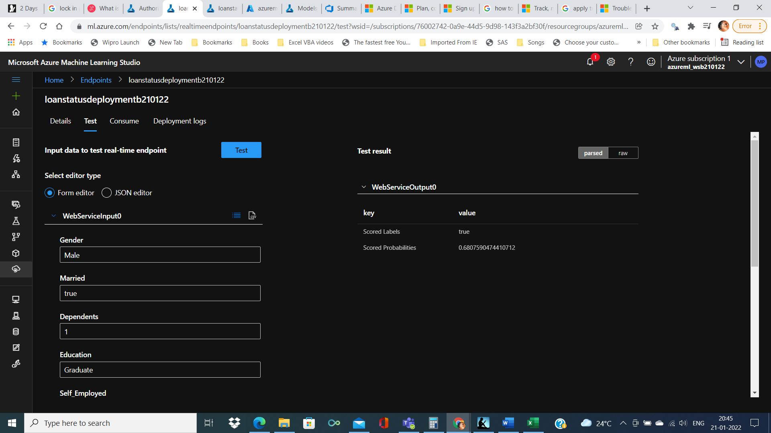

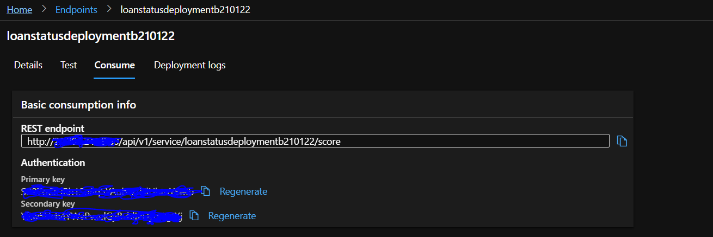ss

It can be consumed using C# or Python or R

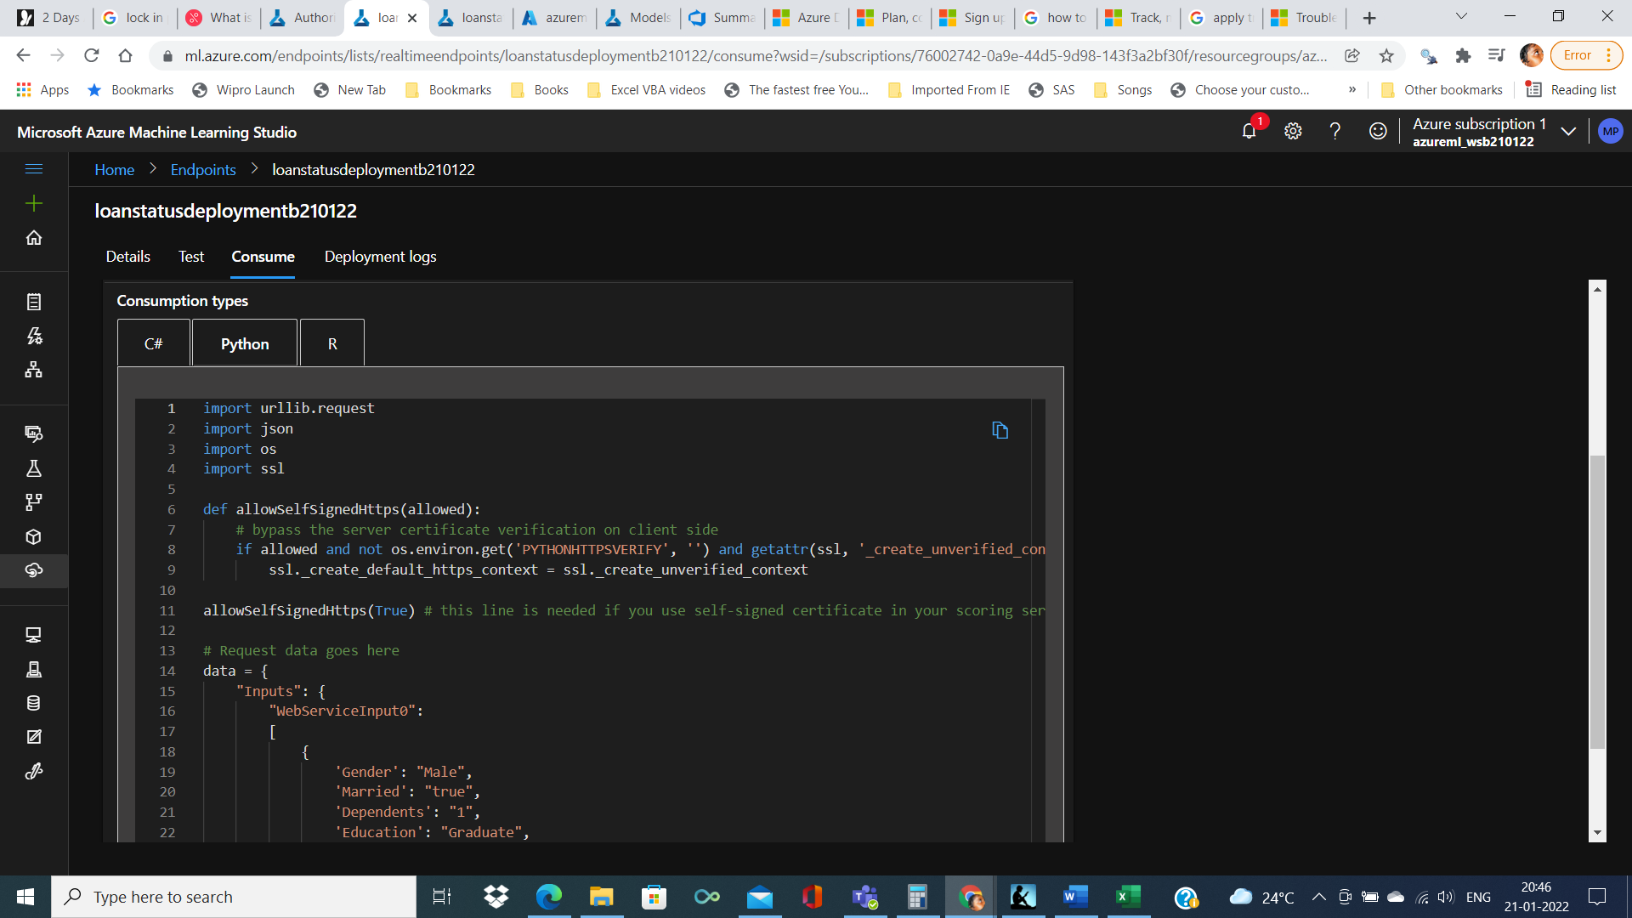

import urllib.request

import json

import os

import ssl

def allowSelfSignedHttps(allowed):

# bypass the server certificate verification on client side

if allowed and not os.environ.get('PYTHONHTTPSVERIFY', '') and getattr(ssl, '_create_unverified_context', None):

ssl._create_default_https_context = ssl._create_unverified_context

allowSelfSignedHttps(True) # this line is needed if you use self-signed certificate in your scoring service.

# Request data goes here

data = {

"Inputs": {

"WebServiceInput0":

[

{

'Gender': "Male",

'Married': "true",

'Dependents': "1",

'Education': "Graduate",

'Self_Employed': "false",

'Property_Area': "Rural",

'ApplicantIncome': "4583",

'CoapplicantIncome': "1508",

'LoanAmount': "128",

'Loan_Amount_Term': "360",

'Credit_History': "1",

},

],

},

"GlobalParameters": {

}

}

body = str.encode(json.dumps(data))

url = 'http://20.204.249.9:80/api/v1/service/loanstatusdeploymentb210122/score'

api_key = 'SR2****************** # Replace this with the API key for the web service

headers = {'Content-Type':'application/json', 'Authorization':('Bearer '+ api_key)}

req = urllib.request.Request(url, body, headers)

try:

response = urllib.request.urlopen(req)

result = response.read()

print(result)

except urllib.error.HTTPError as error:

print("The request failed with status code: " + str(error.code))

# Print the headers - they include the requert ID and the timestamp, which are useful for debugging the failure

print(error.info())

print(json.loads(error.read().decode("utf8", 'ignore')))

In R

library("RCurl")

library("rjson")

# Accept SSL certificates issued by public Certificate Authorities

options(RCurlOptions = list(cainfo = system.file("CurlSSL", "cacert.pem", package = "RCurl"), ssl.verifypeer = FALSE))

h = basicTextGatherer()

hdr = basicHeaderGatherer()

# Request data goes here

req = list(

Inputs = list(

"WebServiceInput0" = list(

list(

'Gender' = "Male",

'Married' = "true",

'Dependents' = "1",

'Education' = "Graduate",

'Self_Employed' = "false",

'Property_Area' = "Rural",

'ApplicantIncome' = "4583",

'CoapplicantIncome' = "1508",

'LoanAmount' = "128",

'Loan_Amount_Term' = "360",

'Credit_History' = "1"

)

)

),

GlobalParameters = setNames(fromJSON('{}'), character(0))

)

body = enc2utf8(toJSON(req))

api_key = "SR27****************" # Replace this with the API key for the web service

authz_hdr = paste('Bearer', api_key, sep=' ')

h$reset()

curlPerform(

url = "http://20.204.249.9:80/api/v1/service/loanstatusdeploymentb210122/score",

httpheader=c('Content-Type' = "application/json", 'Authorization' = authz_hdr),

postfields=body,

writefunction = h$update,

headerfunction = hdr$update,

verbose = TRUE

)

headers = hdr$value()

httpStatus = headers["status"]

if (httpStatus >= 400)

{

print(paste("The request failed with status code:", httpStatus, sep=" "))

# Print the headers - they include the request ID and the timestamp, which are useful for debugging the failure

print(headers)

}

print("Result:")

result = h$value()

print(fromJSON(result))

Deployment logs

